Increasing Stroke Survivors Arm Use in Hospital - A Path to Improved Recovery

Agile Report 3

11th October 2019

# 

**Project Background** **5**

Clients 5

Software Request 5

Users 5

Scope and Requirements for Phase Three 5

**Abstract** **8**

**Introduction** **8**

**The Design Elements of the Final Software Release that Support the Usefulness of the Software for its Target Users and the Ease of Use of the Software for the Target Users** **9**

Design Decisions for Usefulness 9

Design Decisions to Increase Ease of Use 10

Accessibility Design 12

Specific Design Decisions 12

Main Counter Screen 12

“Arm”/“Trigger” Visual and Audio Feedback 17

User Screen 19

User Statistics Overview Calendar 22

Statistics Details Page 23

User Settings Page 25

Bluetooth Settings Page 26

Goal Counter Page 28

Goal Counter Settings Page 30

**The Progress Towards the Technical Development of the Software (DAMIEN)** **32**

What has been achieved? 32

Bluetooth Functionality 33

User Profiles 33

User Statistics 34

Data Exporting 34

Exercise Screens 34

What is ahead of schedule and why? 35

What is behind schedule and why? 36

Button Scalability 36

Custom Training 37

Gamification 37

Unlockables 37

System Activation Button 38

Training Tutorials 38

Achievements 38

**The Process and Outcomes of a Technical and User Testing Phase** **39**

As with the previous cycle the client testing was developed in the same manner. With the first testing session consisting of think aloud tasks. Many of the same success criteria were inherited from previous testing cycles to ensure that the functions and usability of the application was conserved when used on the physical device, as well as new success requirements and tests such as connecting the Bluetooth buttons to the iPad and setting them up for a therapy session. 40

The second round of client testing involved the almost completed application later in agile phase 3 and a simple exploration and navigation session with the client where the whole team worked together to identify remaining issues and areas to polish and assigning them priority values to determine which were most urgently needed; such as data offloading, and which were unlikely to be implemented; such as a stylised and interactive ‘game’ counter. 40

Client testing outcomes 40

Positive feedback 40

Negative feedback 40

Recommended final changes 41

Technical testing 41

Technical testing protocol 41

**A Summary of how the Software Meets the Objectives/Quality/Acceptance Criteria Described in the Initiation Stage** **45**

Objectives 45

Provide a simple counter 45

Communicate with Bluetooth Buttons 46

Goal Page 46

Usability - Patients 46

Usability - Physiotherapists 46

Auditory and Visual Feedback 47

Profiles and Statistics 47

Quality 48

Testing Quality 50

Acceptance Criteria 52

**Conclusion** **54**

**Bibliography** **55**

# 

# **Project Background**

## **Clients**

Matthew Schmidt and John Cannell from Launceston General Hospital.

## **Software Request**

The project brief was to build an iOS application that works alongside Bluetooth buttons designed by Mr. Schmidt in order to record therapy exercises performed by patients recovering from stroke. The application is to have functionality to count the number of repetitions a patient does for an exercise as well as the time it takes them to do so and store the information for review by a physiotherapist. Additional functionality requested by the client includes the ability to set a goal amount of repetitions for patients to complete and/or the ability to set a timer to specify the length of time the activity is performed; as well as possible gamification of the counter functions to make the app more engaging to use.

## **Users**

The users will be stroke patients on ward using the application for self-directed rehabilitation, as well as physiotherapists setting up and inputting goals for patients to work toward. Family members may also assist in setting up the app. It may be difficult for patients recovering from a stroke to set up for rehabilitation exercises on their own.

## **Scope and Requirements for Phase Three**

The requirements for Agile Phase 3, as set out by the project team and the client and altered over the course of Agile Phase 2 are as follows:

● Button Scalability

● Flexible Arm & Trigger Buttons

● Custom Training

● Unlockables

● Application Stability

● Manuals

● Adjustable Arming/Triggering Timing

● ‘System Activate’ Button

● Training Tutorials

● Progression Feedback

● Improved Data Storage

Upon completion of Agile Phase 3, the application will have expended on its current functionality as follows:

1. The application will make use of physical buttons in all areas of the application
2. The application will have a way to modify how those buttons are used
3. The application will have data storage capabilities and ways to modify, access and retrieve that data. As well as a variety of ways to view and plot that data
4. The application gives feedback to the patient to incentivise therapy
5. The application ships with substantial manuals and tutorials

# Abstract

The following document represents the culmination of the past years efforts to provide an application that assists Stroke Survivors in the hospital rehabilitation process. Specifically, this document seeks to inform the reader of the events in the most recent Agile cycle.   
The document will first communicate how the final design of the application meets Human-Computer Interaction (HCI) standards, and how the application was developed for accessibility use as well as design choices for physiotherapist operated sections of the application. The document then goes on to outline the technical progress of the application over the last agile cycle, as well as testing done on that progress. Finally the document concludes with a section on how the project meets the quality and acceptance criteria of the client.

# The Design Elements of the Final Software Release that Support the Usefulness of the Software for its Target Users and the Ease of Use of the Software for the Target Users

## Design Decisions for Usefulness

To further the usefulness of the product, the team has conducted research into elements of Human Computer Interaction (HCI) that revolve around making software and hardware more useful. Usefulness, or usability, is outlined in HCI as “matching the users needs” (Sharp, et al., 2019). To do this, designers must take into account three things; who the users are, what activities are being carried out and where the interaction is taking place. Figure 1 outlines the teams answers to these questions:

|  |  |
| --- | --- |
| Who are the users? | Stroke Patients, Physiotherapists |
| What activities are being carried out? | Rehabilitation Exercise, Application Setup and Data Retrieval |
| Where is the interaction taking place? | Hospital Wards or Rehabilitation Gyms |

Figure 1. HCI Research

Further elaboration on the usefulness of a product reveals that useful products are also “easy to learn, effective to use and provide an enjoyable experience” (Interaction Design, 2018). Communication with the client and user testing revealed how imperative sticking to these principles were. Although producing software with these principles in mind is important, it is especially important in the case of designing for people with limited physical or cognitive ability. As a direct consequence of this, it was important for the team to explore methods of making the application and device more accessible. HCI accessibility research has a focus on disability, specifically in people with long term mental or physical impairments. This research was a major help in the design and production of the application.

Figure 2. Design Progression; Settings Page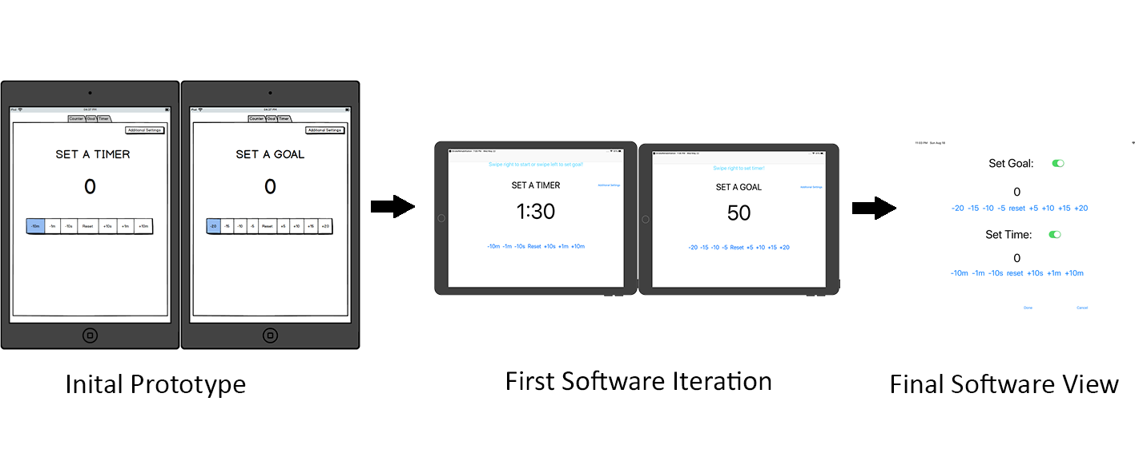

Figure 2 depicts how the team has progressed through many design changes based on both interactions with the client and users, as well as adopting and changing various HCI approaches. The initial prototype was finalised based off the principles of reduced screen clutter, ease of use and intuitiveness. From there, the team implemented a similar design into the application. After technical and user testing phases, as well as client meetings, the design was altered to better match their requirements. The client indicated that they would prefer the settings page to be merged into one page instead of spreading separate settings over two pages. Whilst the clients request was adhered to, there was a need to produce a visual design that was clear, concise and easy to use, whilst still maintaining all on-screen elements. Thus the final version was born.

## Design Decisions to Increase Ease of Use

Ease of use is a key aspect of this project. If the application and accompanying hardware is not easy and intuitive to use, the project will have failed on a fundamental level. The application’s ease of use centres around the User Interface (UI). Increased ease of use came with a simple, clean and visually pleasing UI design. For this reason, the application sought to reduce overloading users by providing a recognition based path through the application rather than one of recall, and encourage different methods of encoding information. Fortunately, the team rarely had to deal with gulfs (gaps between the user and the interface), as the very nature of the device had quite a large gulf.

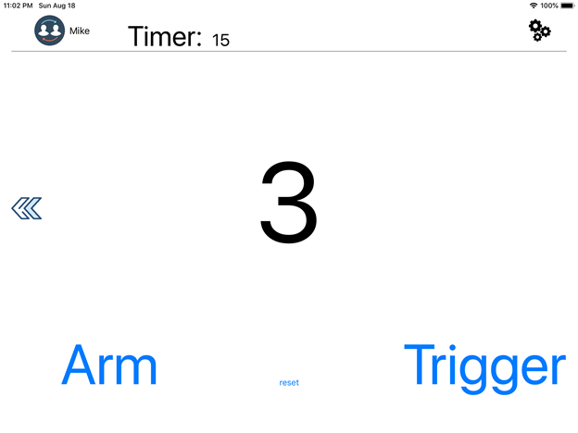

Figure 3. Example of UI Design

Figure 3 depicts an example of an ease of use centered design. Buttons on screen are large with clear text, but also spaced apart to avoid clutter. To increase recognition, common buttons on separate applications, such as the settings or user profile UI widgets, were purposefully located in the standardised areas. Furthermore, elements of the UI that were deemed less important were made smaller and placed in less cluttered areas. Finally, the amount of whitespace on-screen leaves the UI looking elegant and modern.

## Accessibility Design

Because stroke patients struggle both cognitively and physically, the application had to be designed from the ground up with that in mind; however, due to the physiotherapists also utilising the application, there was a requirement to also develop for fully able people as well. Early on in development it was deemed unfeasible and too complex to introduce a togglable accessibility setting in the application. Instead, the team opted to instead develop two seperate parts of the application; one for physiotherapist use and one for patient use; as a byproduct of this decision, physiotherapists are able to use the application in full, whilst patients are limited to only using certain functions. This was a perfect design decision as it allowed the applications setup and settings adjustment to be reserved to physiotherapists, and the actual act of rehabilitation is the only part of the application usable by patients. All screens designed around changing complex settings like adding, editing, or removing patients from databases have been designed for people who are able bodied to navigate, while screens relating to setting, removing and changing goals and timers have been made easy to use for people with less ease of movement.

## Specific Design Decisions

### Main Counter Screen

The main counter page sees the first of many purposeful design decisions present within the application. Figure 4 depicts the main counter screen below:

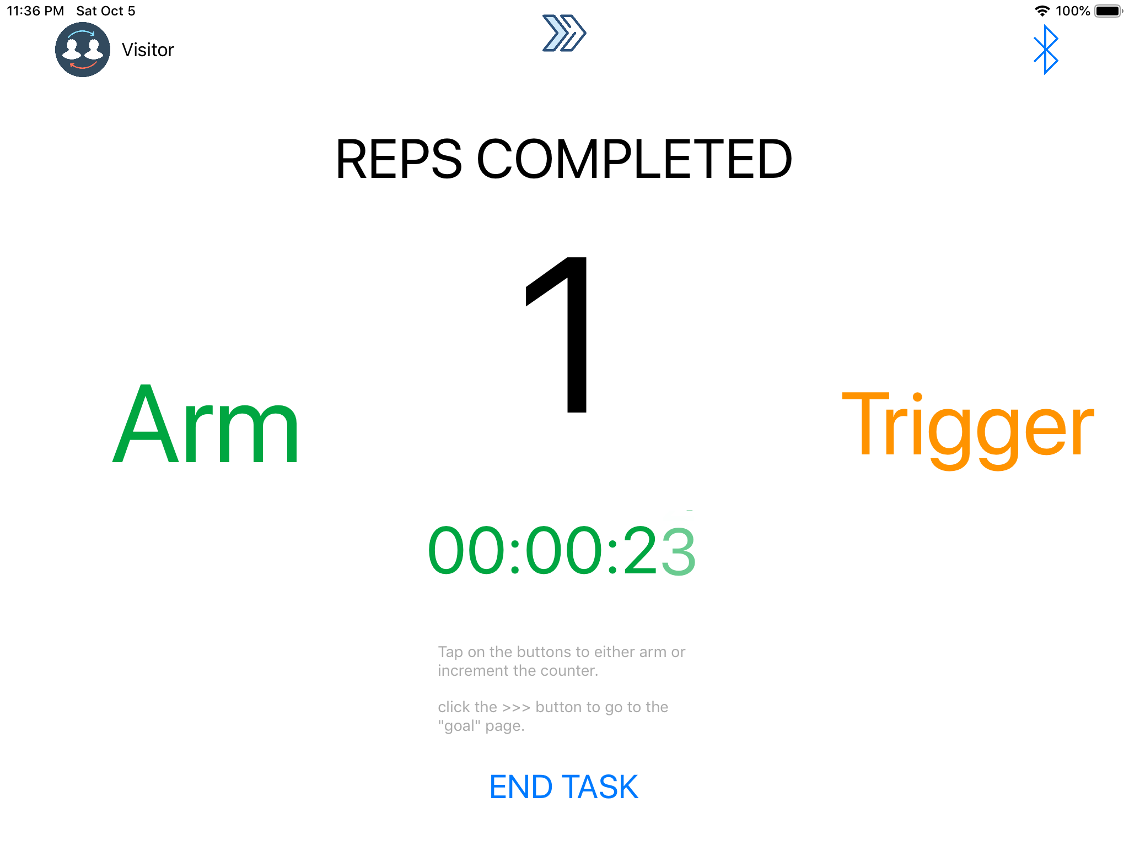Figure 4. Main Counter Screen

The first and most major design decision within the application was the visual representation of the repetitions completed. This number had to stand out to the patient and attract their immediate attention. However, it also had to be small enough not to clutter the screen and the contextual ‘reps completed’ needed to remain clearly visible also. Given that this is the most important piece of information to show to the user, it is the largest element on the screen.

The timer below the repetitions completed indicator in Figure 4 is of secondary importance. This is meant to be a supplementary piece of information that the user may choose to pay attention to or not. If they do wish to take note of the time taken to complete their reps, the timer is relatively large and place centrally on the screen so that the user may find it easily. It is presented in a typical hh:mm:ss stopwatch format and is animated to aid the user in recognising it as a timer. For the user’s convenience, the timer automatically begins when the “Arm” trigger is first pressed, they do not need to start it themselves.

The grey instructional text below the counter shown on Figure 4 contains only very basic information about how to use and navigate the application. The client has stated that having too much text cluttering the page would do more harm than good and that it is important to maintain the clean and simple design of the counter pages. In future iterations of the application, it is likely that this text would be removed entirely and replaced with a separate tutorial page. In its current form, the text is only meant to be read by users who need a refresher on how the application works, and can impart that information to the stroke patient, which is why the text is small and unobtrusive. Currently, the application is designed in a way where the stroke patient would receive training on how to use the application from the therapist, rather than inuiting or figuring out the application themselves.

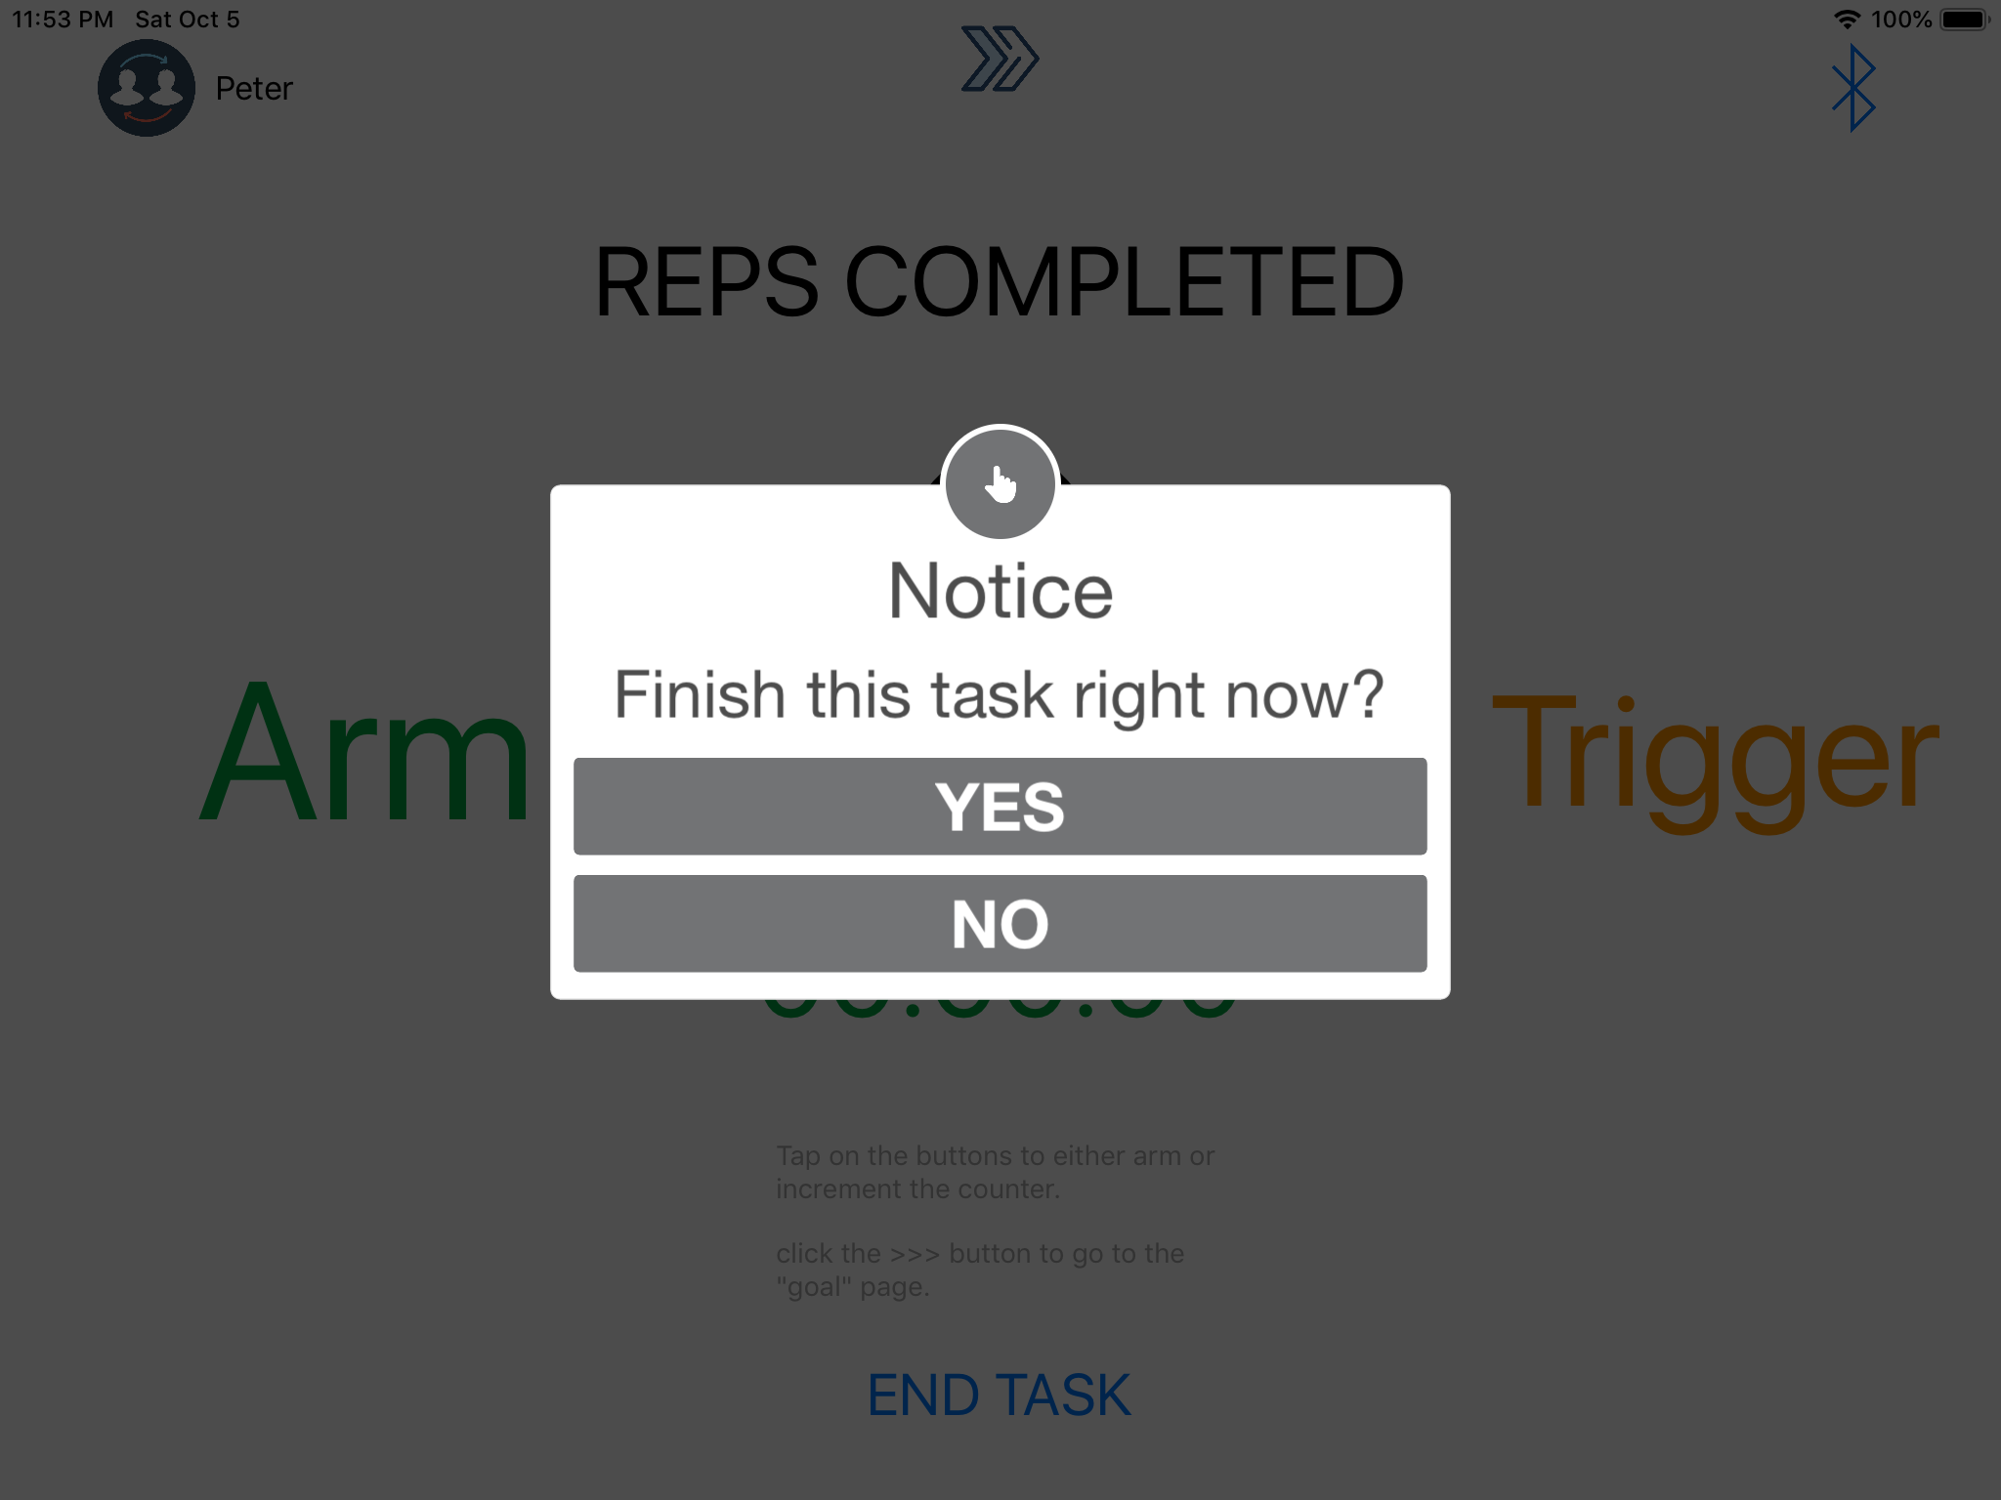

Figure 5. End Task Confirmation Dialogue

The “END TASK” button at the bottom centre of the screen shown in Figure 4 is the only button that the user would have to press during a normal therapy session. This was a deliberate choice because interacting with the iPad itself would be difficult given the position of the iPad and the potential disabilities of the user. Pressing this button ends the therapy session, records it in the database and sets up the screen for a new session. In case this button is accidentally pushed, a confirmation dialogue appears and the user must tap “YES” to finish the session (Figure 5). This dialogue (and others like it) has been kept to a minimum to ensure the user does not need to pay close attention to the iPad screen and can concentrate on pressing the physical buttons. Originally, these dialogues used the default iPad dialogue design, but have been enlarged to make them easier to read for disables users. Some dialogues also do no require touch interaction and are dismissed after a certain time, to reduce the amount of iPad interaction needed.

The three buttons at the top of the screen shown in Figure 4 are designed to be outside of the main navigation path of the application and to be used by therapists wanting to change the parameters of the application and set up more customised sessions, rather than patients accessing this. This is the reason why the buttons are small relative to other elements on the screen, do not necessarily indicate their function, or are they completely obvious that they are interactable. It is intended that these buttons will only be used by therapists and advanced users who are trained in the advanced functionality of the application, and not accidentally used by patients performing therapy.

The icon to the top left of the screen shown in Figure 4 is the user profile icon. The label of this icon changes to the name of the logged in user, to make it obvious who is logged in and, if not, displays “Visitor”. The artwork of the icon, as well as the location of the icon on screen helps to make it obvious that this indicates the logged in user; and that the user should tap this icon to access user profile functionality. The location of this icon is consistent amongst different screens as well, to aid in this. This icon is still small however, to not clutter up the screen and to ensure only users who have made a deliberate decision to access this functionality tap this button.

The right-pointing chevron icon at the top centre of the screen shown in Figure 4 provides access to the goal counter screen. Once again, this icon is small and unobtrusive, but the symbol indicates navigation. This button is this way because navigation to the goal counter page is meant for more advanced users who would already be aware of what this icon does. As an additional prompt, the grey instructional text to the bottom of the screen hints to this icon’s purpose.

The Bluetooth icon to the top right of the screen shown in Figure 4 navigates to the Bluetooth setup screen. Bluetooth functionality is too complicated for the average stroke patient user to set it up by themselves, so this button is intended to be small, unobtrusive and only used by advanced users who are trained in the application’s setup. The Bluetooth symbol is internationally recognised, which is why it was used for the icon for the Bluetooth setup page.

### “Arm”/“Trigger” Visual and Audio Feedback

The “Arm” and “Trigger” buttons to the left and right hand sides of the screen in Figure 4 are the primary methods of visual feedback for actuation of the Bluetooth Buttons. They are large and relegated to separate sides of the screen to indicate they are important and have a separate but related function. The onscreen buttons themselves can be used to increment the counter, or the Bluetooth physical buttons serve the same purpose. The functionality of keeping the onscreen buttons was kept as the client indicated this could be an additional useful way for patients to perform their rehabilitation, rather than having to use the potentially confusing Bluetooth buttons.

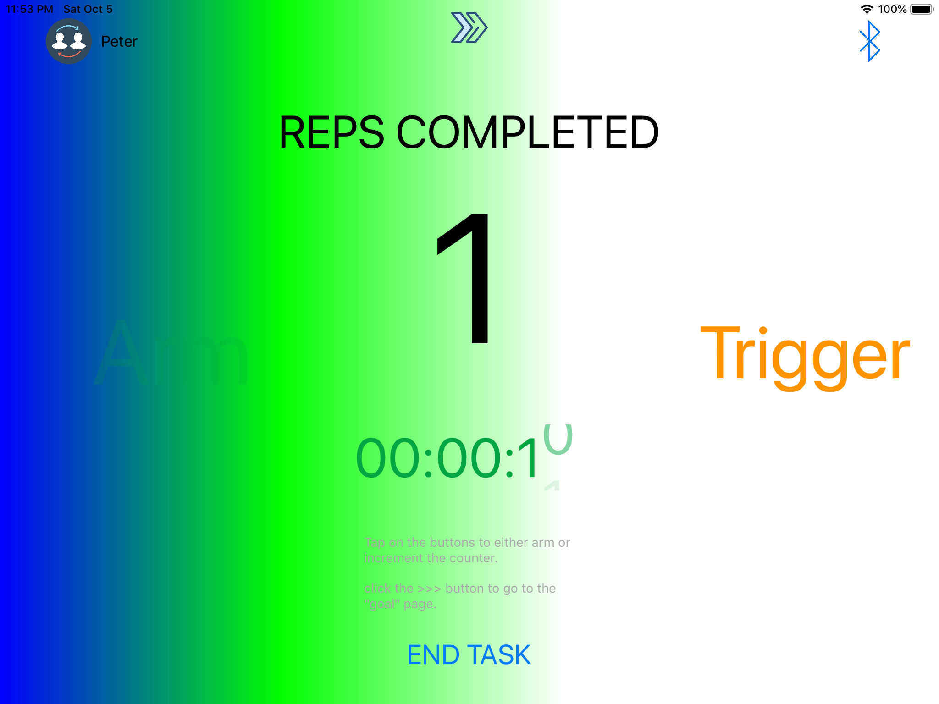

Figure 6. “Arm” Visual Feedback

When the onscreen or Bluetooth “Arm” button is pressed, the left hand side of the screen becomes flooded with a coloured gradient, as shown in Figure 6. The colour remains on the screen until the button is released. This serves very clearly as onscreen feedback that the button has successfully been pressed. Given that the application will likely be used by patients with visual impairments, as well as viewed from a distance, it was important to make the visual feedback striking. It is also intended for the feedback to be visually appealing, satisfying and rewarding to the user, to aid in incentivisation. Finally the visual feedback is used for those who may struggle to hear the audio feedback. Similar to the “Arm” feedback, the “Trigger” button feedback fills the opposite side of the screen with different colours.

Additionally, when the “Arm” and “Trigger” buttons are pressed, audio feedback has been implemented in the form of playing a synthetic tone. A lower pitch tone is played when the “Arm” button is pressed and, to indicate the successful completion of a rep, a higher pitch tone is played when the “Trigger” button is pressed. This serves as additional feedback to help the user recognise when a button has been successfully pressed and when a rep has successfully been completed. It also aids those who are visually impaired to recognise when buttons are pressed. The type of tone has gone through several iterations throughout development, with previous tones being described as too jarring and having a disorenting delay. The current tone that is being used was designed to be soft and pleasant to the ears, but also clear and immediately recognisable as feedback to the user. Finally, in previous iterations, the audio feedback played a higher pitch tone for the “Arm” button and a lower pitch tone for the “Trigger” button. This was swapped as it was determined that the brighter, higher pitch tone better indicated that a full action was successfully completed.

### User Screen

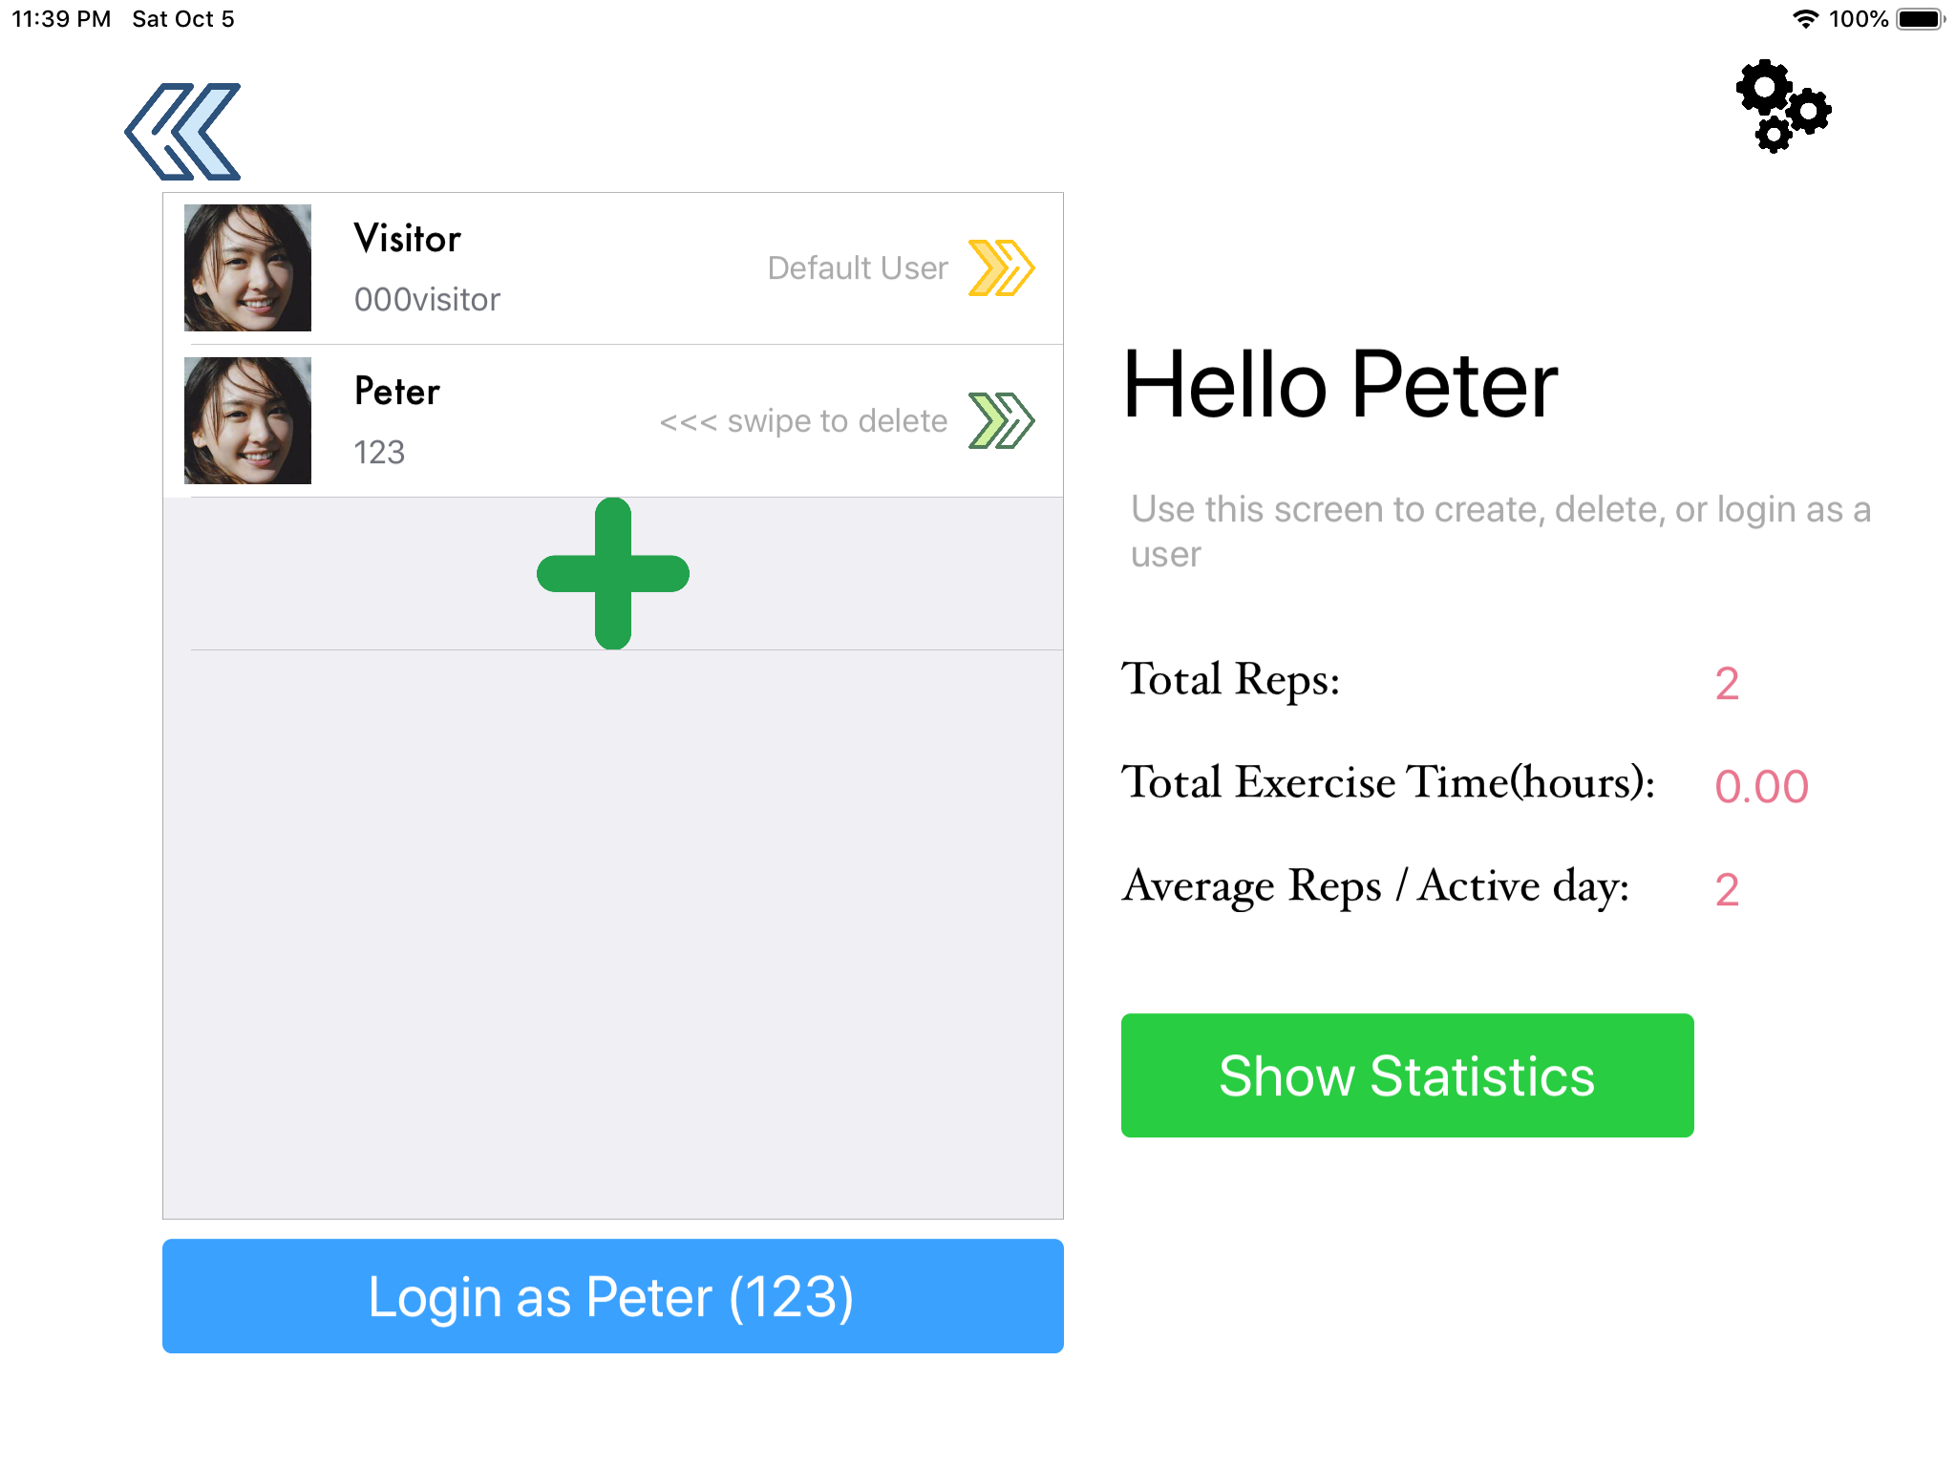

Figure 7. User Screen

Tapping the user profile icon at the top left of the screen shown in Figure 4 displays the user screen (Figure 7). Similar to other screens, it is intended for this screen to be simple and easy to read, but contains more information intended for more advanced users and therapists wishing to manage their patients. It keep similar design decisions to other screens; similar colour schemes, similar icons and minimal information at first.

The level of detailed profile information is fed to the user in three stages. The first and least detailed stage is displayed on the right half of the user screen (Figure 7), under “Hello <username>”. The right-pointing chevrons on the profile list is meant to direct the user’s eyes to this part of the screen once a profile is chosen. This section displays quick information about the logged in profile designed to give the user brief, summarising information about that patient, how much they have performed their therapy and how regularly. The second level of detail is shown when the user taps the “Show Statistics” button under these summarising stats. See Figure 8 for further information.

The left half of the user screen (Figure 7) displays a standard, scrollable iOS style list of user profiles. iOS conventions are kept in place to ensure that the user recognises this as a list that is scrollable, selectable and interactable. The blue “Login as <username>” button is kept close to the list, is the same width as the list and changes as different profile are selected to ensure that the user recognises that this button is closely related to the user profile list. Tapping on a user profile on this list changes the name that appears on the blue button, so that the user knows which profile they will be logging onto. Tapping a profile on the list also darkens that entry on the list, to indicate that profile has been selected. Once a profile is logged on, the “Hello <username>” message changes to indicate the new currently logged on user. The statistics below this also updates. The right-pointing chevron on the logged in profile’s entry on the list becomes green once that profile is logged on, to help confirm this.

The large green “+” icon below the last entry on the user profile list is used to add a new profile. The “+” symbol is commonly used with functionality to add something to a list, so it should be intuitive for the user to know that this button will allow the user to add a new profile. The fact that the button is inside what looks like an empty entry in the list should help indicate its purpose too.

Each user profile entry in the list contains a small message that indicates to the user that they should swipe left on the entry should they wish to delete that entry. This is consistent with many standard mobile application gestures to delete from a list.

The left-pointing chevron at the top left of the user screen shown in Figure 7 indicates a back button. Like other navigation icons in the application, the arrows pointing left should intuitively indicate to the user that they should press this button to go back to the previous screen, in this case the normal counter screen. It is located at the top left as this is a common location for the back button on iOS applications.

To the top-right of the user screen (Figure 7) is the button to access user profile settings. It utilises a universally recognisable “cogs” icon so the user should easily understand that it is a settings button. The icon style and its location on screen is kept consistent with other settings pages in the application. It is also relatively small and unobtrusive to help ensure that only users who know what the settings functionality is actually access it.

The small, grey text underneath the “Hello <username>” title is meant to simply prompt the user to remember and recognise what the user profile page does. It is not meant to provide comprehensive instructions on how to use the page. While many aspects of this page has been designed to be intuitive, it is expected that most users accessing this page has had prior training in its use.

### User Statistics Overview Calendar

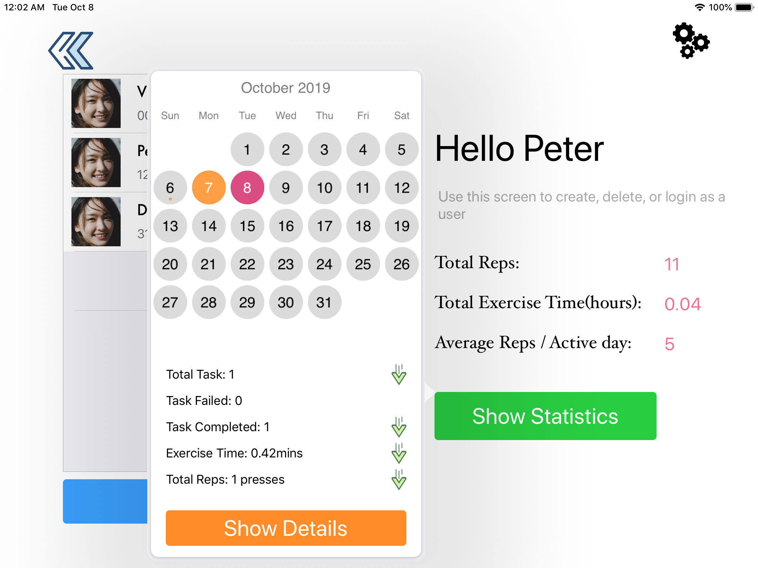

Figure 8. User Statistics Overview Calendar

Tapping the green “Show Statistics” button shows the statistics overview calendar for the logged-in user (Figure 8). This is designed to give the user an idea of the patient’s activity for each day and is the second level of detail that the user may view a patient’s statistics. It uses a standard calendar design so most users should be able to intuitively understand how to interact with it. The calendar is presented as a popup to indicate that this is additional information but still closely related to the user profile screen. The calendar popup causes the view behind it to darken slightly to make the calendar clearer onscreen and to indicate that the background view is currently inactive.

Tapping on a day displays summarising information about the therapy that was performed on that day, including how many sessions, the total number of reps performed and the total time spent performing therapy. When a patient has performed less therapy than the previous day, the chevrons point downward to indicate this. When a patient has performed more, the chevrons point upward to indicate positive progression. This allows the user to see at a glance the patient’s progress on a given day. When a day has session information associated with it, there is a small orange dot on that day on the calendar, which is a common method to indicate events on a digital calendar. The currently selected day becomes highlighted orange to help the user understand which day’s information they are looking at. To help with understanding days of the month and their relation to today, today is highlighted purple.

### Statistics Details Page

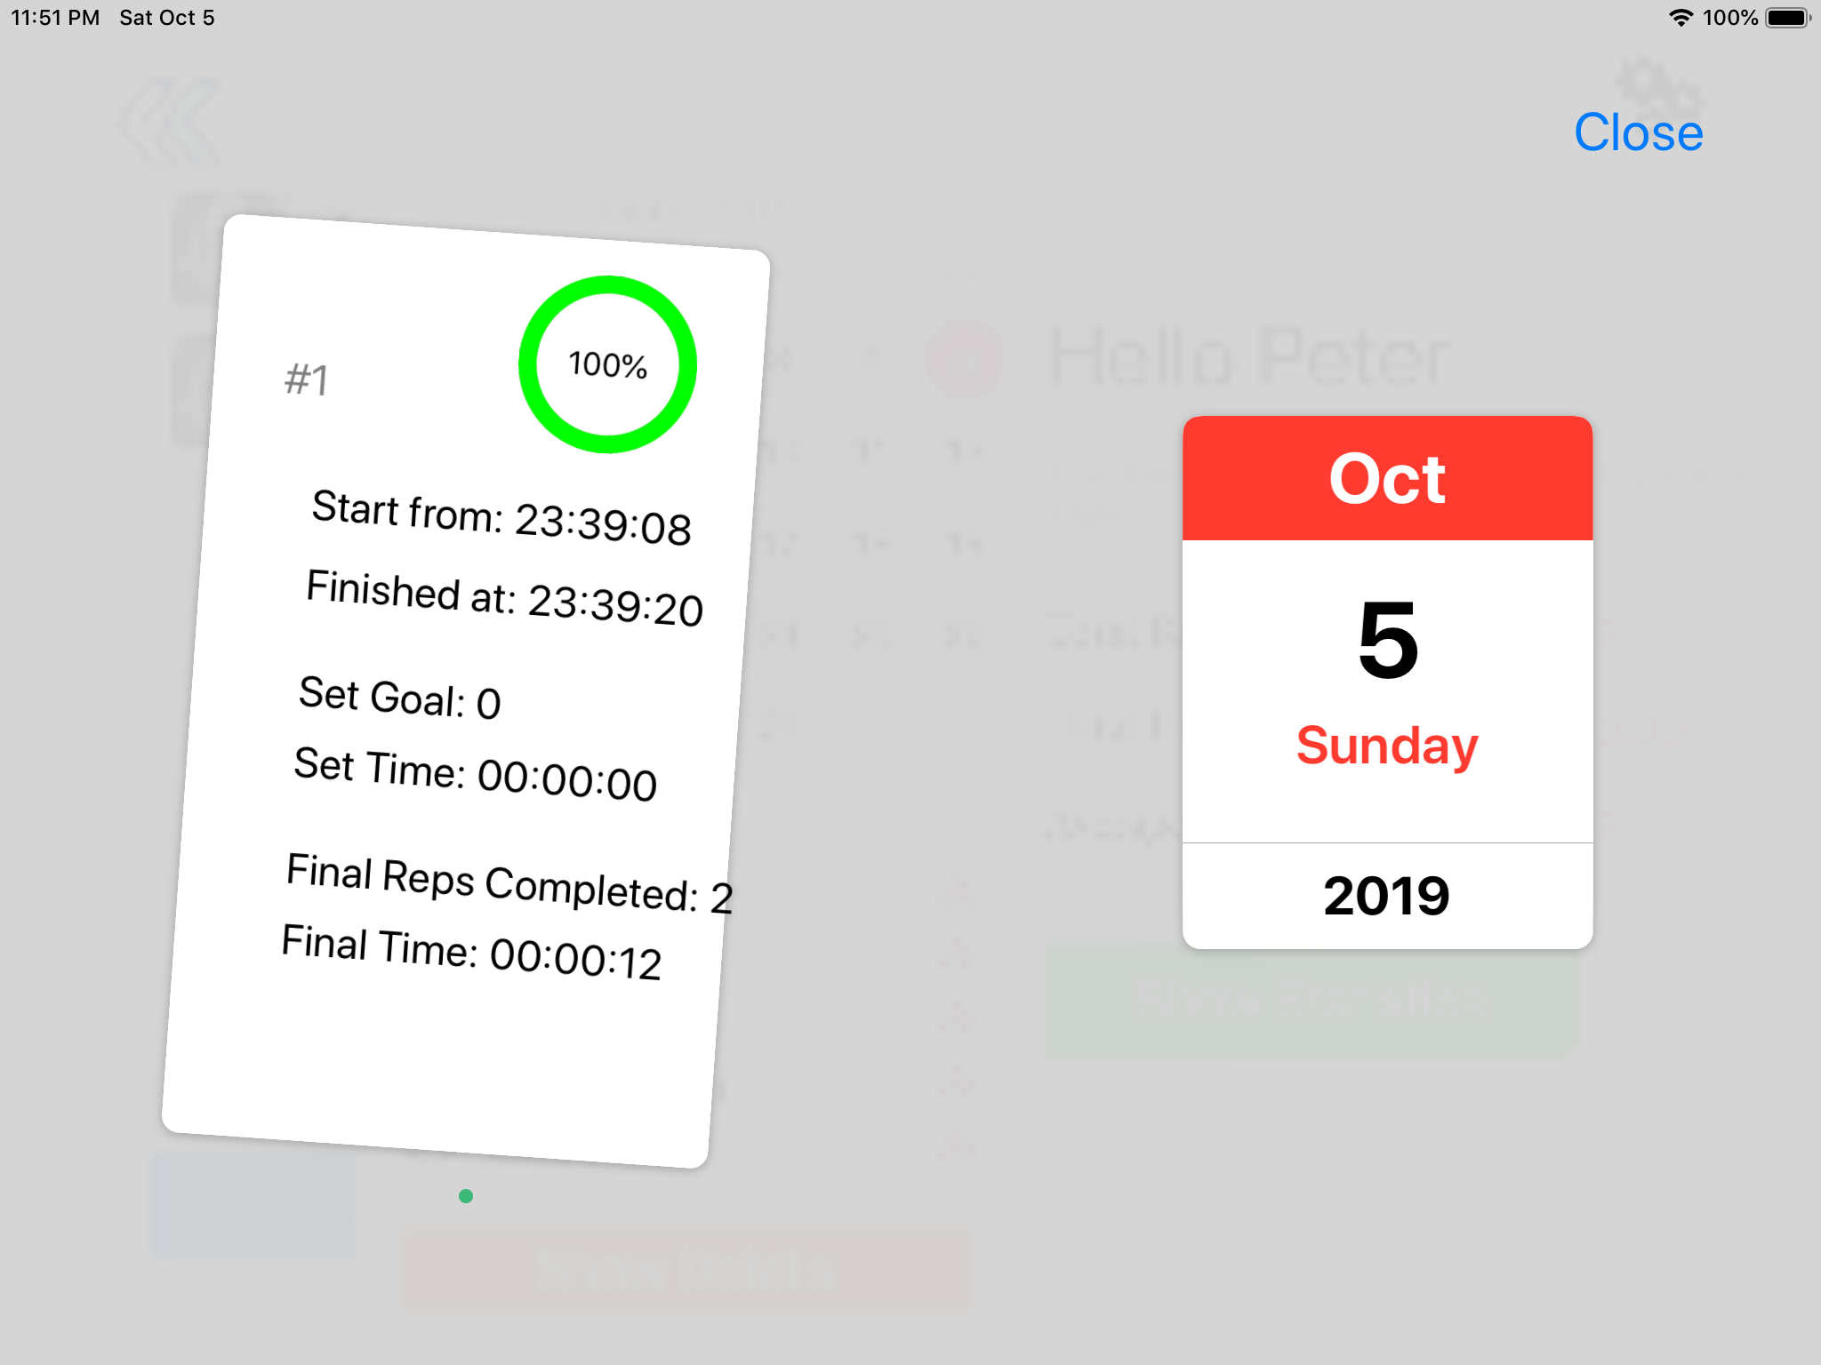

Figure 9. Statistics Details Page

The third level of detail that a user may view of a patient’s statistics is the Statistics Details Page, shown in Figure 9. This page shows details about every session that was performed on the day that was selected on the calendar. Each session is visualised as a card on the left hand side of the screen. When there are multiple sessions completed in a day, the cards appear stacked so the user can tell that there are multiple cards to see. When the user touches a card, the card appears to be picked up and is dragged along with the user’s finger. This indicates to the user that cards can be swiped away to reveal the card beneath it. Dotted page indicators also appear below the card to assist the user in understanding that a swiping gesture is needed. Each card is numbered to the top left, so the user can see how many sessions there have been in the day. The circular indicator should be recognized by the user as the same one in the goal counter screen, indicating how much of the session was completed before it was ended. The rest of the information on this screen shows all recorded details of the session, including start and finish times, whether a time or rep goal was set, how long the session took and how many reps were completed. This information is quite elemental, as this is the most detailed level of statistics the application can provide.

The background view is greyed out to indicate that this screen in inactive, yet still closely related to the current view. As a reminder to the user as to which day’s statistics they are viewing, a calendar widget showing the relevant day is shown on the right hand side of the screen. Finally, a simple and easy to find “Close” buttons appears in the standard iOS location at the top right of the statistics details page.

### User Settings Page

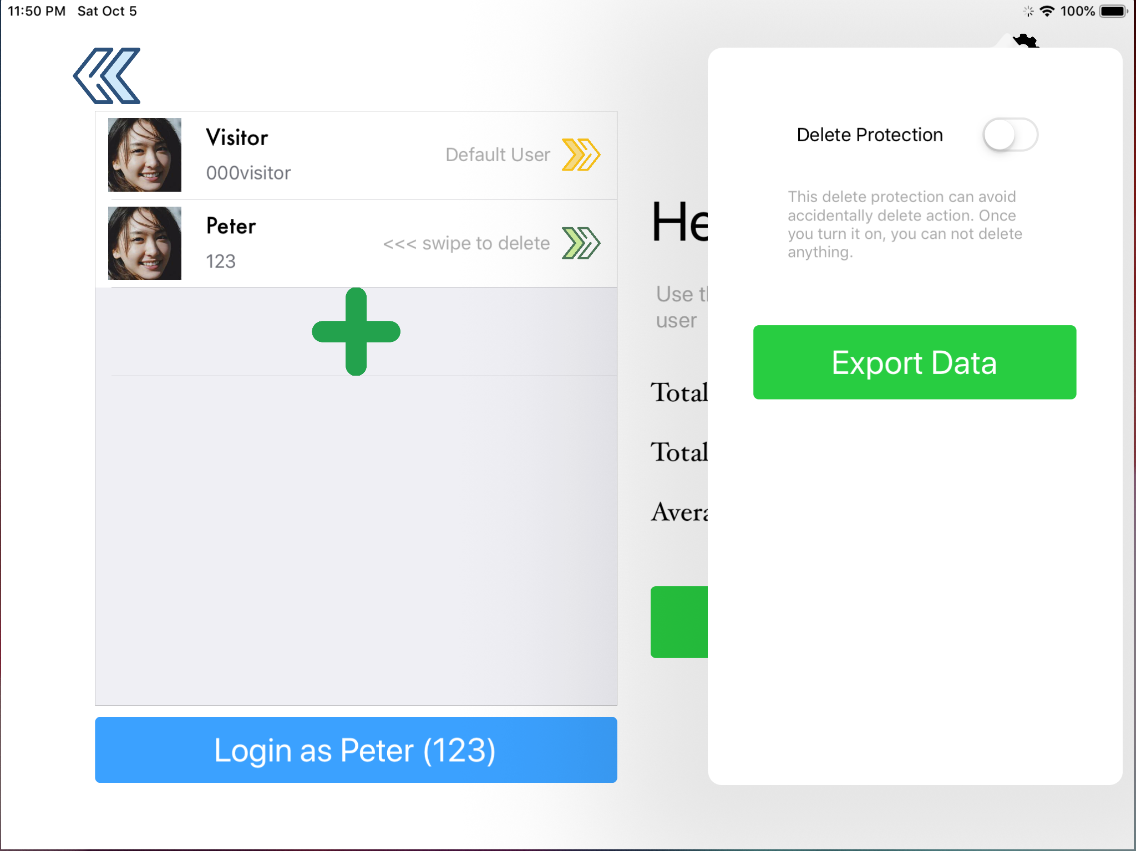

Figure 10. User Settings Page

Tapping on the “Cogs” icon at the top right of the user screen (Figure 7) opens the user settings page, as shown in Figure 10. It opens in a bubble style popup and greys out the user screen to show that while the background is inactive, the settings in the popup are closely related to the background view. The “Delete Protection” switch is accompanied by instructions so the user understands its functionality. Having additional text in this view is acceptable because it is sufficiently away from the standard user path of the application which must be kept simple. It uses an iOS default switch to clearly indicate to the user that this settings can be turned on and off by tapping the switch. It is also the same style of switch the appears elsewhere in the application, to aid in consistency. The “Export Data” button is advanced functionality and is not expected to be used by people who have not yet been trained in its use. It navigates the user to standard iOS sharing menus and dialogues so it should be recognisable and usable to any trained person familiar with iOS devices.

### Bluetooth Settings Page

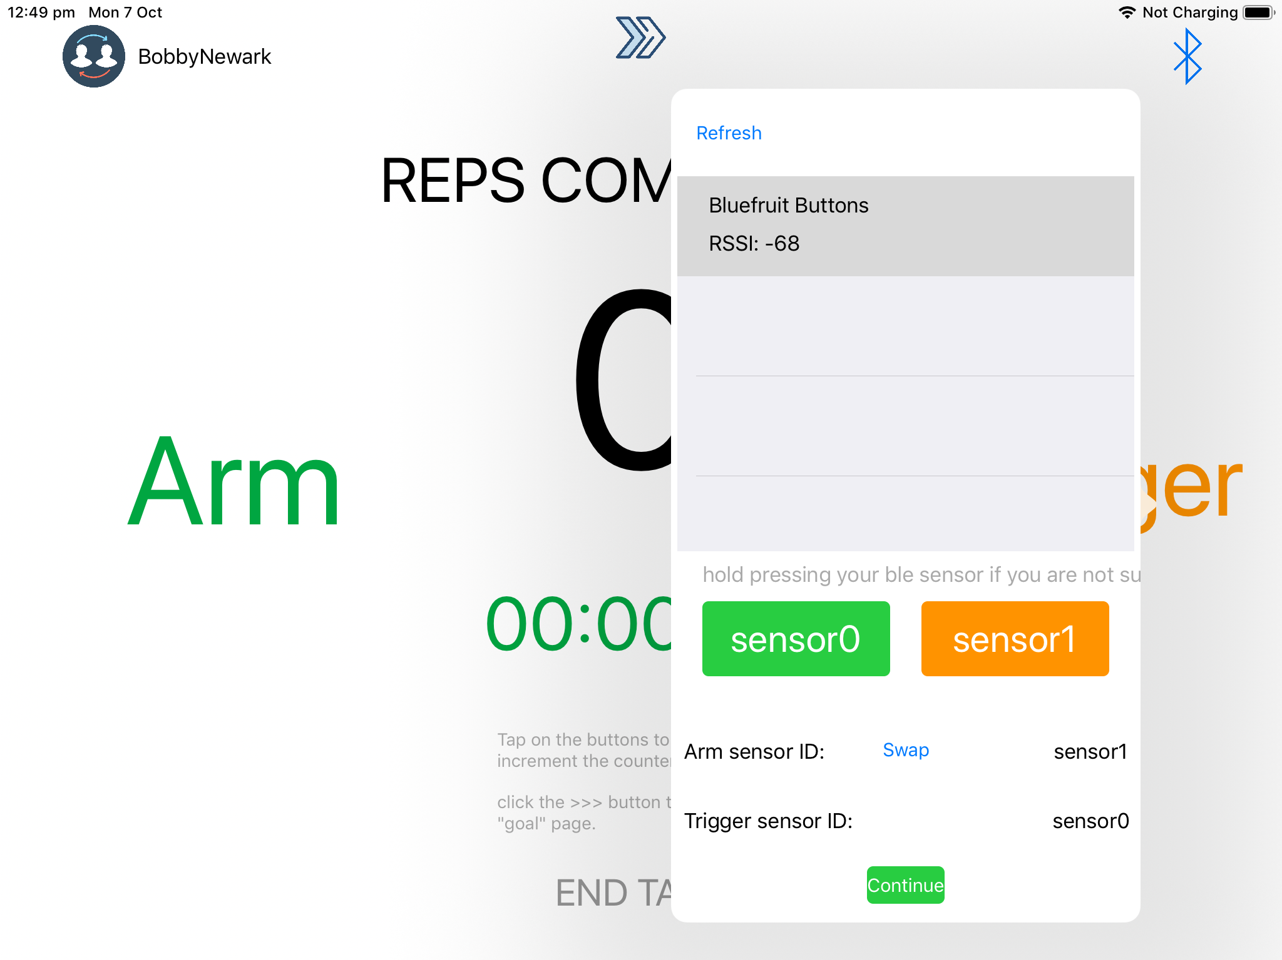

Figure 11. Bluetooth Settings Page

Tapping on the Bluetooth icon from the main counter screen (Figure 4) takes the user to the Bluetooth Settings Page. This is one of the most advanced pages in the application and should only be accessed by a trained user who needs to set up Bluetooth for the first time. Due to its advanced nature, many of the elements in this page are unintuitive. It does however maintain style consistencies with other views in the application, with a simple layout and a popup bubble design.

The standard iOS style list in the centre of the popup shows all of the available Bluetooth devices and provides their name and their RSSI (signal strength). The user should be able to intuitively recognise that they can select a device from the list. If the Bluetooth buttons do not appear in the list, it should be obvious to the user to try the “Refresh” button above the list. Once the correct device is selected, the user may tap the green “Continue” button at the bottom of the screen to finish setting up the buttons.

If the user wishes to set the buttons up further, they may utilise the lower half of the Bluetooth settings page. Scrolling grey text below the device list informs the user that they may hold down one of the Bluetooth buttons to help determine which physical button is recognised as “sensor0” by the application and which is recognised as “sensor1”. Holding a button down highlights either the green “sensor0” button or the orange “sensor1” button, so the user can tell which is which. Once the user identifies which physical button is which, they can determine which button performs the “Arm” function and which performs the “Trigger” function using the text below the green and orange buttons. By default, sensor1 performs the “Arm” function and sensor0 performs the “Trigger” function. The standard iOS blue “Swap” button between these labels should be obvious to the user that this will swap the button roles. If not, the user can easily experiment with this button to figure out its functionality.

### Goal Counter Page

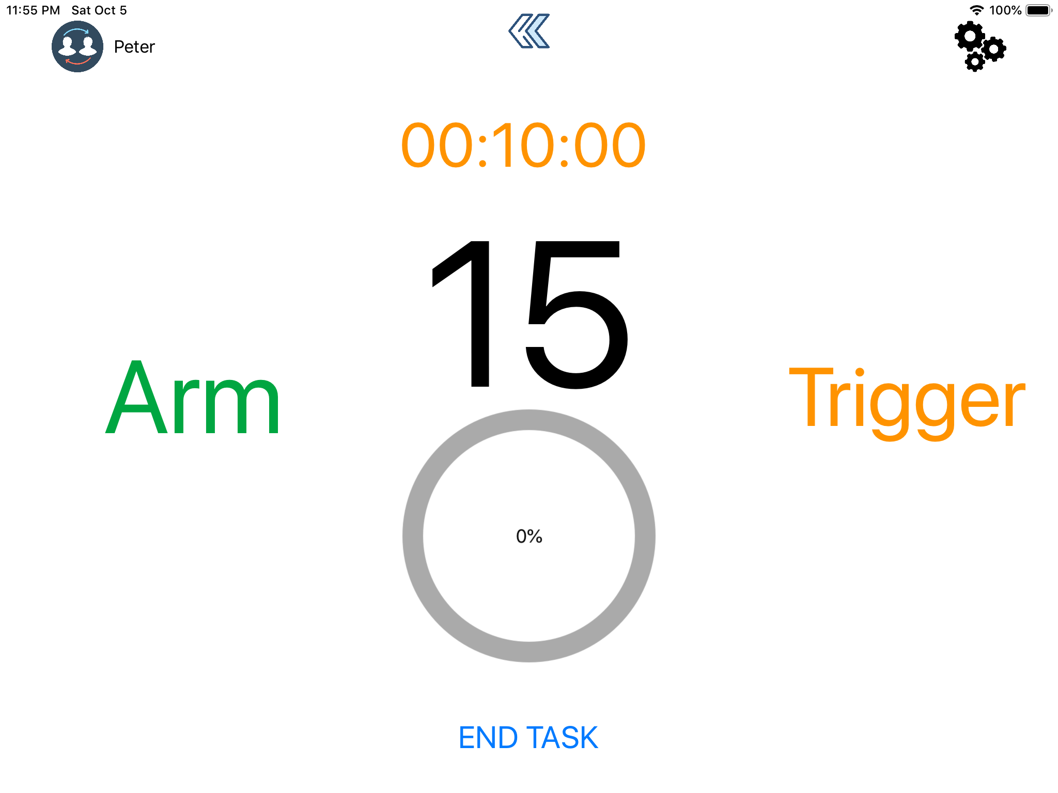

Figure 12. Goal Counter Page

Tapping on the right-pointing chevron on the main counter page (Figure 4) takes the user to the Goal Counter Page, as shown in Figure 12. This page is designed to be extremely similar to the normal counter page, except the user may choose additional parameters to set for the session. Its similarity is deliberate to ensure that the user understands that the functionality of this screen is similar to the normal counter screen and so as to not confuse the patient who may be performing therapy on either screen.

The rep indicator and timer on this screen has very similar functionality to the normal counter screen except, if a rep or time goal has been set, the corresponding counter will count down from the set value, rather than up from zero. This is a simple way to display time and rep goal values without cluttering the page with additional numbers. It should be intuitive to the patient that these numbers are counting down instead of up once they start their session.

Additional information is also displayed on this screen in the form of a circular progress bar below the rep indicator. This was placed as an additional indicator to the patient of their progress through the session. Seeing the bar fill up as they complete their reps is meant to encourage the patient to continue and complete as many reps as they can or to complete the entire session. This was indicated by the client as a powerful incentivisation method and an effective way to communicate progression within a session to patients who are more visually minded rather than numerically minded. It will also be more readable for patients with visual or cognitive impairments. If a rep goal has been set, the circular progression bar will track rep progression. If a goal has not been set but a time limit has, the circular progression bar will track the time left. This is designed to allow for multiple measurements of progression to be shown with a single onscreen element, minimising screen clutter.

Tapping the left-pointing chevron at the top centre of the goal counter page takes the user back to the normal counter page and essentially works as a back button. This is similar to other back buttons in the application so its functionality should be easily recognisable to the user.

### Goal Counter Settings Page

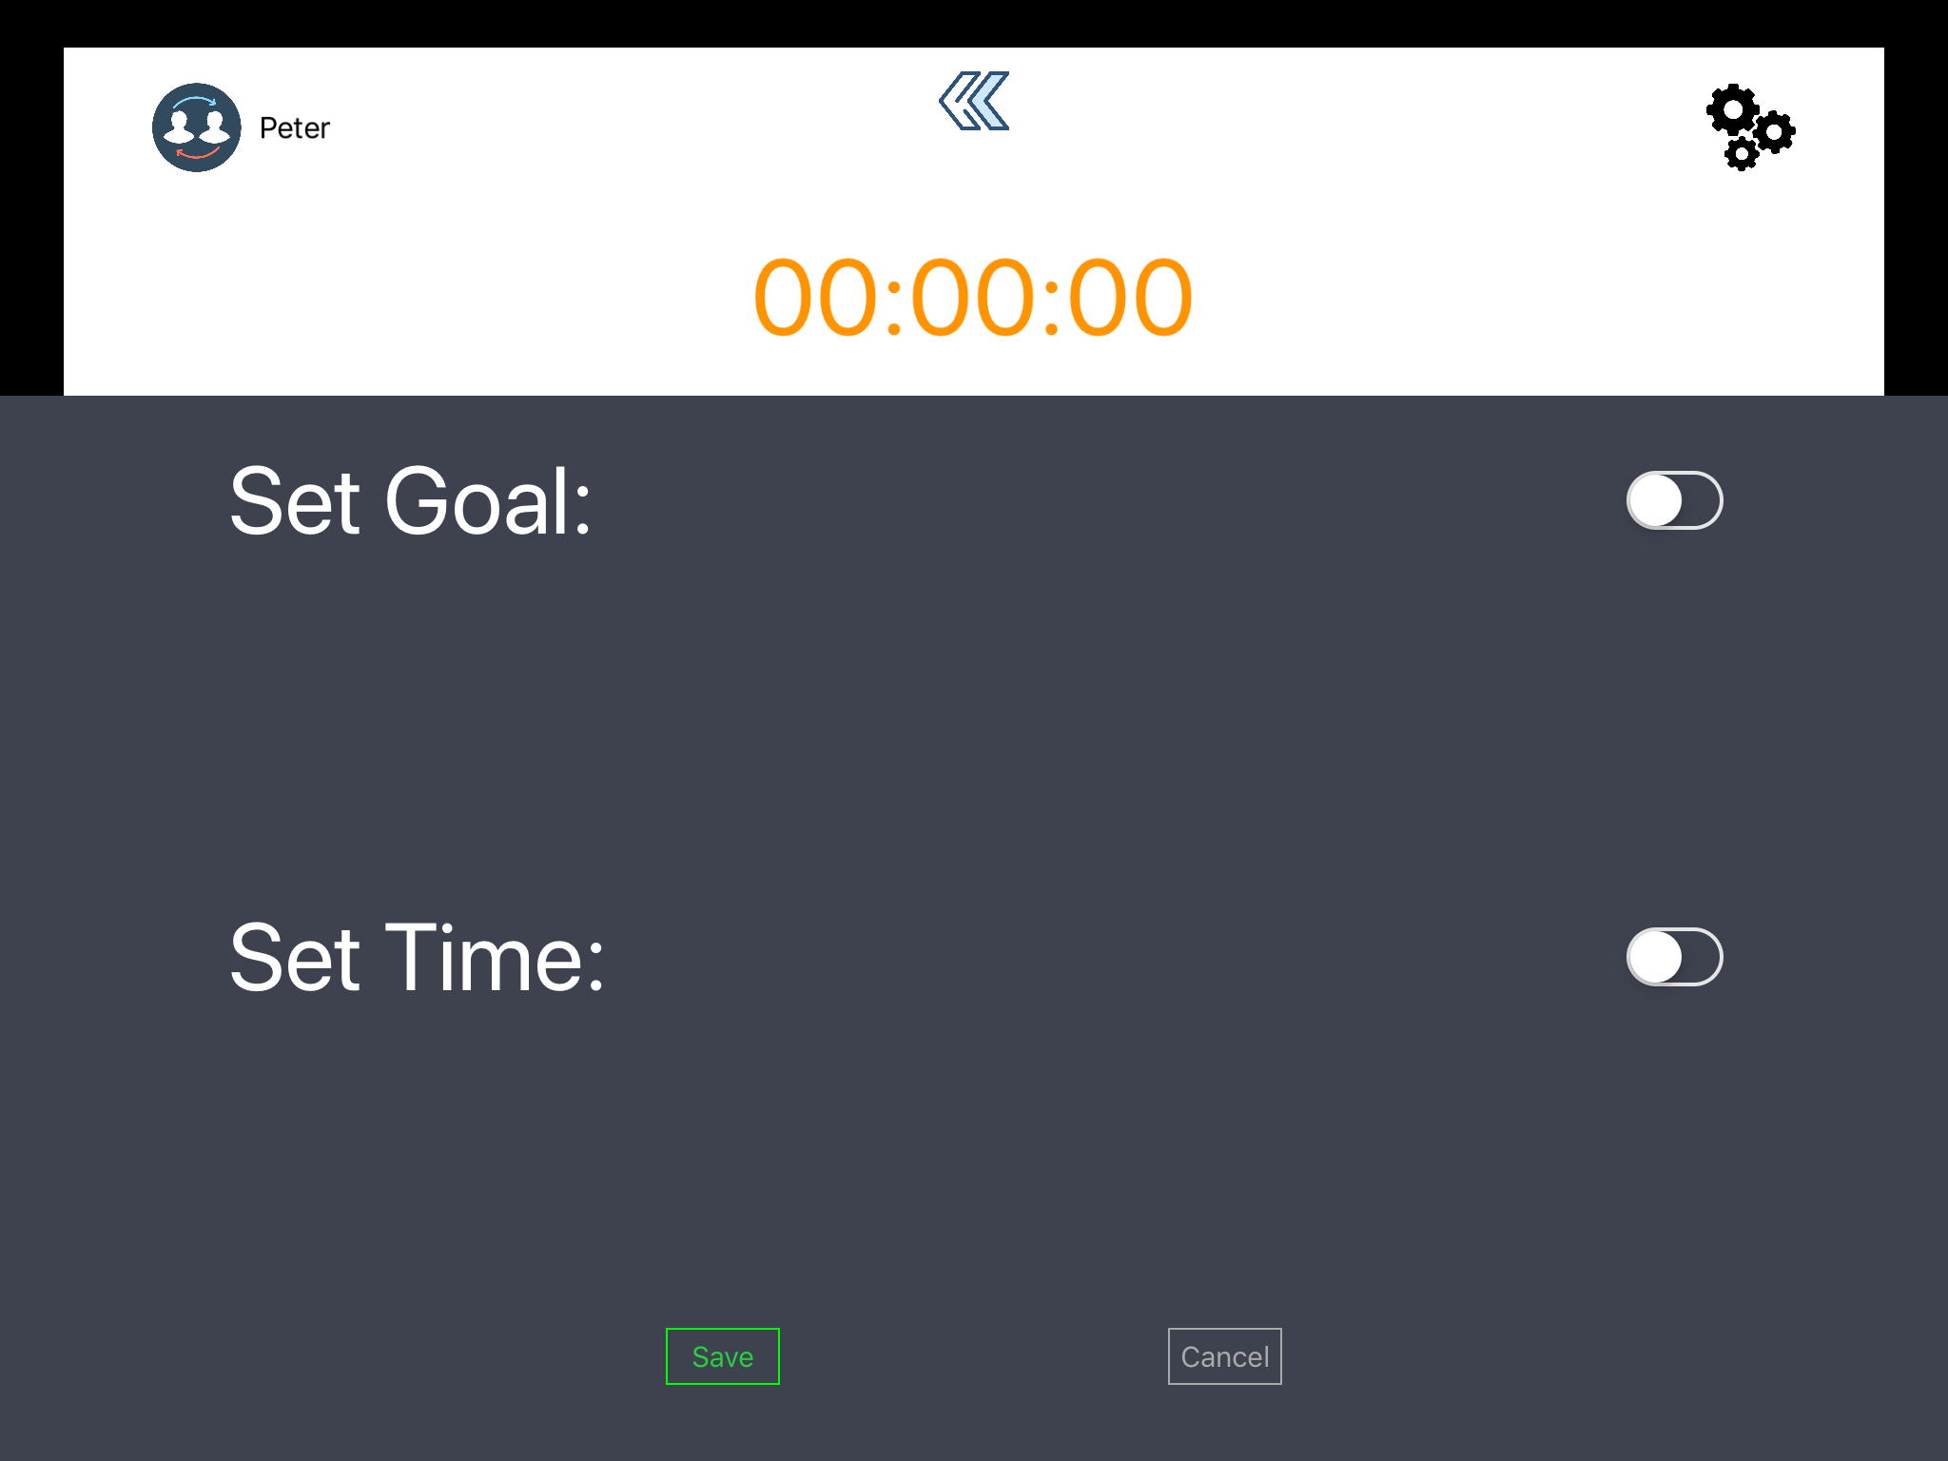

Figure 13. Goal Counter Settings Page with Switches Off

Tapping the “cogs” icon to the top right of the goal counter screen reveals to the user the Goal Counter Settings Page, as shown in Figure 13. This page pops up in front of the goal counter screen but keeps it visible to indicate to the user that this settings page directly affects the page behind it. When the goal counter settings page is first opened, there are two iOS style switches associated with setting the time and setting a goal that are set to the off position by default. This should indicate to the user that they may choose to set a goal or a time, or both, or neither.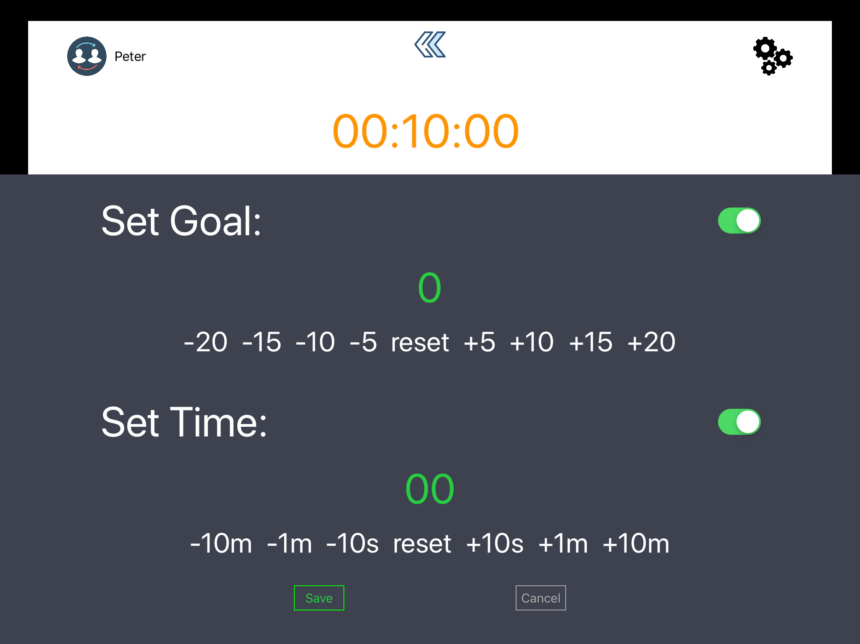

Figure 14. Goal Counter Settings Page with Switches On

When a switch is tapped to the on position, an indicator and a set of buttons is revealed to allow the user to set a goal or time. Tapping on one of the white values below the green indicator increments the counter by that button’s value. This was designed to be a simpler way to input values into the application, rather than having to use an onscreen keypad, as this was determined by the client to be difficult for many users to operate. The four goal increment buttons and four goal decrement buttons have been set to values that, after testing, has been determined as the most useful to set likely chosen values; as is the case with the 6 time buttons. In the centre of each row of value-setting buttons is a “reset” button which will reset the corresponding indicator’s value back to zero. This is an easier and more intuitive way to zero out the values rather than having to hit the correct decrement buttons. The time indicator adheres to standard hh:mm:ss stopwatch formatting to aid in recognition that this is a time value.

Instructions are minimal on this page as it is expected that the user accessing this page has had training on its use, and would not need onscreen instructions after they have used the page several times prior. The “save” button to the bottom left of the screen is highlighted green to better indicate to the user that they must press this button for their settings to be saved. To better indicate to the user that their settings have been saved and the state of the application has been changed, the goal counter settings page is dismissed once the “Save” button is pressed, revealing the goal counter page with the user’s inputted values set.

# The Progress Towards the Technical Development of the Software

## What has been achieved?

The final agile phase has resulted in significant progress on the application. Many new features have been added, while existing features have been refined and improved based on client, user and team testing that occurred during this agile phase as well as during agile phase 2. The majority of this agile phase has been spent refining current features to a standard acceptable by the clients and the users, as well as adding many additional features that were specified as must have requirements during scope specification in the planning phase of this project.

### Bluetooth Functionality

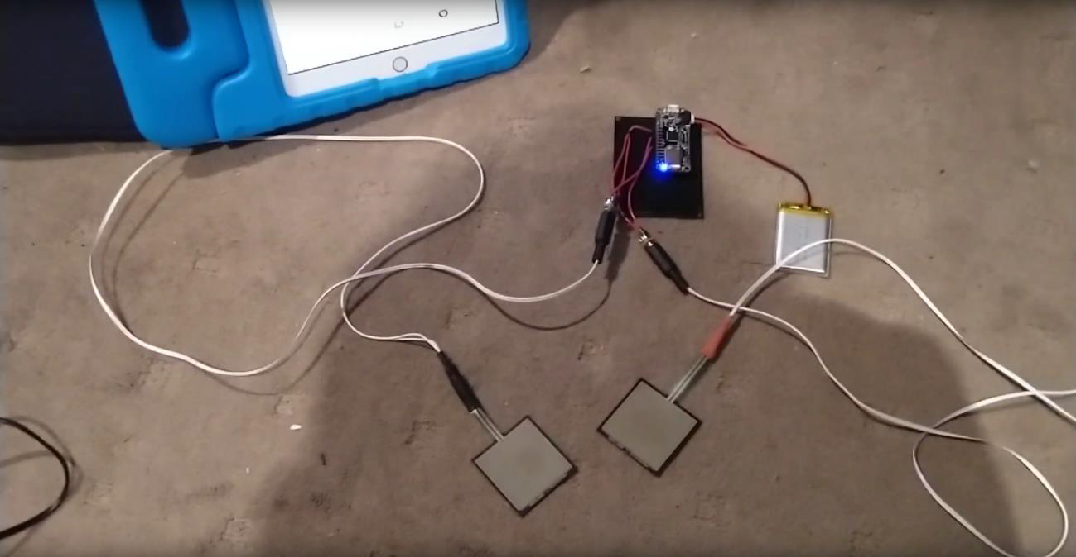

Figure 15. Bluetooth Arduino Force-Sensitive Touchpads

Full Bluetooth functionality has now been implemented. After several phases of development issues surrounding having proper Bluetooth functionality implemented into the application in such a manner so that it meets client requirements, the application now fully supports the force-sensitive Bluetooth touchpads to supplied by the client to serve as the “Arm” and “Trigger” buttons of the application (Figure 15).

The application contains a separate Bluetooth settings screen accessible from the main screen. This screen is used to initially connect the Bluetooth buttons to the iPad, as well as providing information that allows the user to identify which physical button is considered the “Arm” button by the application, and which is the “Trigger” Button. This screen also allows the user to switch the role of each physical button to either “Arm” or “Trigger”.

### User Profiles

User profile functionality has remained mostly the same as agile phase 2, but has received several small changes as a result of client testing and further development time. A “Delete Protection” function has been added to the settings page of the user profile page to prevent the user from accidentally permanently deleting a user profile, as suggested by the client. Some summarising statistics about that user’s exercise activity is now shown on the user profile page so the user can quickly see a patient’s activity levels and proges.

### User Statistics

A significant amount of change has been made to the user statistics functionality of the application. Exercise information can now be viewed from three levels; per session, per day and per user. The user statistics that are shown are also now more clear, easy to read and useful to the user.

Per user statistics are viewed from the user profile screen. Once a user is selected and logged on, information about that user’s exercise activity is provided on the right hand side of the screen. This is intended to be a fast and easy way for the user to see summarising information about the patient. The Show Statistics button now displays session data in a calendar format. The user can select a date and view summarising information about the therapy exercises performed on that day. If the user wishes to see information about a specific session, they may tap the Show Details button for that day and see swipeable pages which contain detailed information about every session that took place during that day for that user.

### Data Exporting

Once a profile is logged in, the user may choose to export the session information about that user via the settings page for the user profile screen. Tapping the Export Data button produces two comma-separated values (.CSV) files which uses the built-in iPad file saving functionality to save the files on the iPad or in iCloud. One files contains summarising information about each session that was recorded for that user, including start and finish times, set goals, and achieved reps. The other file contains detailed information about each button press event that occurred for each session for that user, including timestamps, which button was pressed, and which session it occured. This information can be saved elsewhere for information security or further analysed and visualised to gain further insight into the patient’s recovery.

### Exercise Screens

The two main exercise screens of the application have retained essentially the same functionality as prior agile releases. The majority of changes improve usability and provide more effective feedback after button presses. The Main Counter Screen now contains a timer that begins when the user presses the “Arm” button, as requested by the client. Both the Main Counter Screen and the Goal Counter Screen now also have significantly improved feedback. For example, upon actuation of the “Arm” button, multicoloured light flashes on the side of the screen which contains the word “Arm”. The “Trigger” button provides similar feedback on that side of the screen.

Audio feedback has also been improved. Several testers have commented that the sound that plays when the buttons are pressed is jarring. Testers have also stated that the significant delay that occurs is disorienting. Finally, testers have requested that the lower pitch sound be played for the first “Arm” action, and the higher pitch sound be played for the second “Trigger” action, as this is more intuitive. The old guitar note sound has been replaced with a softer synth note sound which is less harsh, shorter and does not contain a delay. The pitches have also been reversed.

The Main Screen now saves session data to the logged in user profile when the “END TASK” button is pressed. All exercise sessions which are begun are now recorded, as the client stated information on how a user interacts with the application could be useful, even sessions which were not meant to be “real”.

A circular progress bar was also added to the Goal Counter Screen to further add feedback to the progression of the therapy session. It was stated by testers that a visual representation of feedback was more useful than numbers, especially to stroke patients with limited cognitive ability or technical capability.

Error messages when the user presses buttons in the incorrect order have been removed. This is to make the application appear more friendly and allows the user to better explore the correct way to operate the application, with assistance from the therapist. Removing error messages also reduces the requirement to use the touch screen on the iPad also, something which has been stipulated as important by the client. Similar to this, messages which pop up on screen, such as when a session is completed now time-out by themselves and do not require interaction with the iPad to dismiss. Messages such as this have also been made larger to better aid those viewing the iPad from across the therapy surface with limited eyesight.

## What is ahead of schedule and why?

It was determined at the end of agile phase two that it was unlikely that the project team would be able to implement any form of fully functioning gamified version of the stroke rehabilitation application. Attitudes toward gamification have also changed significantly over the course of development. Both the clients and the project team feel that gamification is something that has a large amount of risk associated with it for this type of health application. It has the chance of implementing negative persuasion as well as creating an unnecessary difficulty barrier for the application.

Despite the decision to leave major elements of gamification for future iterations of the application, some progress has been made on creating early working prototypes of games that could be played to encourage the “Arm” “Trigger” movements that is the primary purpose of the base application. One prototype is a “Whack-a-Mole” style of game where actuation of the Bluetooth Buttons results in an on-screen hammer swinging down to hit a small animal. Another prototype is a rhythm game style of system where on-screen symbols associated with a Bluetooth button move towards the player. The player must then hit the correct button when the symbol gets to the right position on the screen. These prototypes will be delivered to the client as extra material that they may wish to further develop in the future.

Given that is is the third and final agile phase of this project in its current form, the team has not placed any emphasis on developing any other aspects of the application beyond the scope outlined in the Planning Report. Instead, the team has focussed on completing all requirements that were first scoped in the Planning Report and most recently reviewed and adjusted in the Agile Phase 2 Report.

The task of implementing progression feedback has been a significant element of this agile phase. Rep progression feedback for the duration of a session, as well as feedback on the overall progression of the patient for the therapist to view and analyse has been extensively worked on and implemented. In association with this, the task of improving data storage has been successfully implemented with the ability to export session and user information off of the iPad and into other devices and software for further analysis and visualisation.

Application stability is an ongoing task that is beginning to reach a satisfactory level as agile phase three closes. Ongoing testing is proving that the application should be at a state where it is usable and reliable enough for use in its intended environment.

Manuals and the final agile phase report are a significant element of this agile phase. All required documentation are on schedule for completion and delivery to the client at the end of agile phase three, at a satisfactory level of quality.

## What is behind schedule and why?

There have been a number of requirements there were scoped during the planning phase of this project that have been delayed significantly. At this stage of the project, some of these requirements will not be delivered by the end of this agile phase. Throughout the iterative development of the application, some of these requirements have also been altered in their importance and relevance, which has also altered their priority and subsequent level of completion at the end of the final agile phase.

Below is a list of requirements that are behind or unfinished as of writing this report:

### Button Scalability

The ability for the application to support more than two buttons was planned at the initiation stage of the project. However, the priority of implementing this requirement was reduced as other issues arose in development and other requirements such as usability needed more attention. In addition to this, additional hardware buttons were never developed or made available to the project team. While the project team could have still developed this without having additional physical buttons, it would have been more difficult, less predictable and harder to test. The project team anticipates that this requirement would be fulfilled relatively quickly and easily should this application enter further development in the future.

### Custom Training

The concept of preset, custom training sessions in the application has become somewhat redundant as the application has evolved. Originally, this was meant to be a fast and easy way for the user to have access to different types of exercise sessions without having to spend time setting complicated parameters or game modes. With the heavy emphasis on simplicity that has arisen throughout development, the requirement for preset custom modes is no longer needed. This is because the application in its current state only has two simple parameters to set anyway, a time and a number or reps. It is not necessary to have preset modes when setting up a session is already extremely simple. Should more complicated types of therapy, gamification, or long term session plans be implemented into this application during future development, then the concept of custom modes may be worth reconsidering.

### Gamification

Gamification was a concept that was desired by the client as early as the initial brief. As the application evolved, attitudes towards gamification changed amongst the client and the project team. Overall, many forms of games or gamification has now been deemed as overly complicated and poses a risk of causing negative persuasion and discouragement for the user. The concept of “losing” and showing negative progression has been determined as extremely detrimental to a stroke patient’s recovery process. While some elements of gamification such as achievements, feedback and unlockables may still provide benefit, these concepts currently have a low priority. Further research and development will be needed to successfully and safely implement gamification in this application.

### Unlockables

During the early phases of development, unlockables were brainstormed as an effective yet unpunishing method of implementing gamification and realising its benefits. While this requirement is still valid as a Nice To Have; after client and team discussions, the priority of this and other gamification strategies has been significantly reduced. The client has stressed many times that keeping the application as simple as possible is very important for the client to be able to comprehend the rehabilitation activity required of them, without distractions and complications. It was a higher priority of the development team to focus on usability and making the base assets as effective as possible. Adding a multitude of arbitrary and untested sounds and effects would serve to jeopardise the usability of the application, its simplicity, as well as the effectiveness of the audio and visual feedback. Should future developers have the resources to implement this carefully and effectively however, the project team could still recommend adding the feature.

### System Activation Button

A “System Activation Button” was always an important requirement to implement once multiple physical buttons had been developed. This requirement was designed as the primary way for the application itself to prevent the user from “cheating”. This was to be done by making the user constantly hold one button down with one hand, forcing them to use only their other hand to move between the “Arm” and “Trigger” buttons. Since this requirement is dependent on the button scalability requirement, this could not be developed. The project team anticipates that once the button scalability requirement has been implemented and multiple physical buttons are available, the “System Activation Button” functionality would be extremely easy to implement. Until the requirement is fully implemented, the project team recommends informing therapists and users that the patient should try to touch the buttons using only one hand.

### Training Tutorials

In-app training tutorials were suggested by the client during the testing of the application during agile phase two. This was then added to the list of requirements as a Nice To Have for agile phase three. Due to the time constraints of this agile phase, as well as the requirement to refine and add other more fundamental requirements, this requirement never eventuated beyond initial brainstorming and discussions with the client and within the project team. Should the development of this project continue beyond this agile phase, the project team would highly recommend this requirement be a top priority. This is because the client suggested it as an extremely useful and intuitive way to train users in the application’s proper setup and operation, especially when the application’s use-case extends beyond the hospital setting and into people’s homes.

### Achievements

Achievements would be one of the most unobtrusive ways of implementing gamification. Its effectiveness in incentivising users to use the application more and providing positive persuasion is not known, however. Because of this and the change in attitude of implementing gamification into the application, this requirement has been given a low enough priority such that it has been shelved in favour of implementing and refining other more important requirements. Should future developers wish to implement this and test its effectiveness, many of its dependent requirements are already implemented for the realisation of basic achievements. The application already records a significant amount of information about every therapy session performed for every user and stores it in an internal database. This information can easily be used to create a multitude of achievements including, total rep milestones, speed of reps, number of sessions in a day and “Arm”/“Trigger”/“Arm” consistency.

# The Process and Outcomes of a Technical and User Testing Phase

As with the previous two phases of agile development, the team continued with the same testing format for the final stage of the project. This included think aloud testing with both clients and users as well as technical testing by the team itself. A notable aspect of this testing phase is that it was the first testing phase where Bluetooth functionality was implemented and the application was running on a physical iPad. This brought to light several usability and ‘quality of life’ points of feedback from the client in particular, related to on-screen text and button press feedback.

Client testing protocol

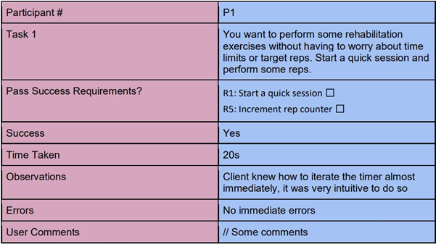

Figure 16. Client testing think aloud template

As with the previous cycle, the client testing was developed in the same manner. The first testing session consisted of think aloud tasks. Many of the same success criteria were inherited from previous testing cycles to ensure that the functions and usability of the application was conserved when used on the physical device. Success requirements to test new functionality such as connecting the Bluetooth buttons to the iPad and setting them up for a therapy session were also created.

The second round of client testing involved the almost completed application later in agile phase 3. A simple exploration and navigation session with the client where the whole team worked together to identify remaining issues and areas to polish was also conducted. Identified problems were then assigned priority values to determine which required addressing most, such as data offloading; and which were unlikely to be implemented, such as a stylised and interactive ‘game’ counter.

### Client testing outcomes

### Positive feedback

Overall, the client was very happy with the final phase and fully developed version of the application. In terms of feedback for changes from the previous agile cycle, the client was happy with both the quality of life changes, as well as overall project-side development ideals. Adding deletion protection to the user accounts and the further simplified view and navigation of the app were seen as very positive changes by the client.

Negative feedback

The following is a list of the changes that were noted down from the two sessions of client testing the team set up:

* The client requested that the text is made larger (certain text within the application is too small).
* The client outlined a concept for having a switch that when activated disables help boxes and text for repeat users.
* The client mentioned the possibility of including more animations within the application.
* The client identified that the sound plays after a delay when pressing the button which is off-putting when trying to complete an exercise.
* Potentially change the sound to a click (change the arm trigger sounds).
* The client notes that the sound is quite jarring and obnoxious and requests a different sound to be implemented.
* The client asks for a key / legend to be added for the application in order to show the user what each icon means.
* The client notes that many of the important pieces of information on the statistics screen are quite small when displayed and requests that they be made larger.
* The client suggests that the background or text colour for a day in the statistics screen changed to indicate that exercise had been completed, that would be better.
* The client notes that the statistics page is a little confusing, as it is currently sorted in reverse chronological order.
* The client requests that if a user interacts with the main counter screen rather than the goal-oriented screen that the exercise also be recorded.
* The client requests that for each day have the total number of ‘reps’ completed, with a cumulative total showing on each account within the app.
* The client asks that the application provide a nice clean easy summative statistic (this is currently lacking).

### Recommended final changes

As can be seen from the negative feedback taken from client testing notes, the recommended changes all fall into two categories. There is that of adding parts to increase application usability, and that of polishing the application in its final state. The project team is taking all of the client feedback into account as many of them fall in line with the last changes that the team had identified and planned to carry out.

## Technical testing

### Technical testing protocol

For the application to meet the quality and stability requirements expected by the team and the client, a set of white-box tests were designed and then carried out towards the end of development. These tests focus on the software’s structure and internal stability rather than its usability and conciseness, like the user testing did. As with the previous agile cycle, the team used these tests to demonstrate that the application was both error free and had satisfied the requirements identified during user mapping.

To begin with, the static analysis tests were repeated from the previous phase. This was to ensure that errors had not appeared within the application due to the further development carried out during this final phase. These tests are as follows:

*1.1 Check the logical correctness of the code. Determine whether the code has errors and whether data structures are effectively implemented to meet requirements.*

*1.2 Ensure the input parameters are checked for correctness. All edge cases and invalid input should be accounted for.*

*1.3 Error handling. Every block of code should predict the conditions that lead to errors, and the appropriate error handling methods should be used. Once the program fails, the program should be able to recover without crashing and all data should be preserved.*

*1.4 Conformance to naming conventions. Ensure that variable names are intuitive, succinct, normative, easy to remember, and easy to spell.*

*1.5 Check whether in-code documentation is complete, clear, concise, and whether it correctly reflects the function of the code.*

The team then designed a new set of test cases in order to run through functions that had been added during phase 3 and check them for expected outcomes as well as application flow through these processes.

The functions that were added in phase three that test cases were designed for are:

|  |  |
| --- | --- |
| Test Case | Bluetooth functionality |
| Use Case | SW Use Case 1: Application_Supports_Bluetooth |
| Description | Connect the Bluetooth buttons to the application and set them up to be used for a session of therapy. |
| Criteria | 1. The Bluetooth buttons can connect to the iPad 2. The application allows the user to designate the arm button and trigger button 3. The application saves the settings set in step 2 and runs using that button mapping |
| Method | **Black box**   1. Open the application 2. Turn on the Bluetooth buttons 3. Press the Bluetooth icon within the application 4. Connect the buttons to the app from the Bluetooth screen 5. Designate the arm and trigger buttons by pressing them in sequence and checking to see if the identifiers on the screen light up 6. Confirm the mapping of the buttons and exit to the main counter screen |
| Outcome | **PASS -** The buttons can be connected to the application and, if the user requires, can be swapped so that the arm and trigger button are reversed. |

|  |  |
| --- | --- |
| Description | The application displays users statistics |
| Use Case | SW Use Case 2: Application_Shows_Statistics |
| Criteria | 1. The application saves statistics 2. The application shows data specific to the desired user 3. The application displays the data in the correct place |
| Method | **Black Box**   1. Log into the desired users profile 2. Perform some rehabilitation 3. Ensure that the rehabilitation session ends with ‘End Task’, after completing the reps or after the timer runs down 4. Navigate to the users statistics profile 5. Check the base statistics 6. Check the statistics overview and calendar 7. Check the statistic details |
| Outcome | **PASS -** All saved data persists and is located in the correct place |

|  |  |
| --- | --- |
| Description | Data can be offloaded onto a computer |
| Use Case | SW Use Case 3: Data_Offloads |
| Criteria | 1. The application saved data 2. The application interacts with a computer 3. The applications data can be accessed 4. The data is viewable on the computer |
| Method | **White Box**  Tests func exportData();   1. Navigate to the user profile screen 2. Open the profile settings menu 3. Select ‘Export Data’ 4. Observe output and check for: <userID>_Mission_List.csv <userID>_Button_Events.csv 5. Attempt to open these files in *Microsoft Excel* |
| Outcome | **PASS -** Files contain the correct data and offload onto the target machine |

|  |  |
| --- | --- |
| Description | The application provides auditory and visual feedback |
| Use Case | SW Use Case 4: Application_Provides_Feedback |
| Criteria | 1. The application provides visual feedback on button press 2. The application provides auditory feedback on button press 3. The application provides visual and auditory feedback upon progression |
| Method | **Black Box**   1. Press the ‘Arm’ Button 2. Observe and listen for feedback 3. Press the ‘Trigger’ Button 4. Observe and listen for feedback 5. Observe progression feedback |
| Outcome | **PASS -** The application provides full auditory and visual feedback. |

# A Summary of how the Software Meets the Objectives/Quality/Acceptance Criteria Described in the Initiation Stage

## Objectives

The application meets the required objectives, as outlined by the client. User and client centered design and development has ensured that the application adheres to all required objectives and standards. Below is a summative list of all required objectives and functionality, as well as a brief description of how they were achieved:

### Provide a simple counter

At its basic level, the application provides a simple counter than can be incremented via the physical buttons provided by the client. This counter functions correctly, and also utilises sound as a form of incentivisation. Furthermore, the application has the added functionality of a reset button.

### Communicate with Bluetooth Buttons

The application communicates with Arduino powered capacitive buttons, as provided by the client. As these buttons are actuated in the correct order, the counter displayed on-screen will increment with them in. The Arduino that the buttons are connected to emits a small field Bluetooth signal that is recognised by the accompanying iPad application as a custom Bluetooth controller. As the buttons are actuated, each individual sensor is recognised by the iPad and the appropriate button is actuated in app.

### Goal Page

The application implements a fully customisable goal page that allows a physiotherapist to set the amount of repetitions a user does, as well as the amount of time they have to do it in. To compliment this page, a settings screen was also included which enables users to set the number of repetitions, as well as a timer. If the user desires, they also have the option of disabling the timer completely.

### Usability - Patients

Although usability has already been spoken about within the document, it will be briefly mentioned here as well. To increase the overall usability of the application for the physiotherapist, the team has separated the application into two distinct areas. The main area is for patient use, which includes the main counter page and the goal counter page.

### Usability - Physiotherapists

The second area of the application exists mostly in the back end. This area is designed for physiotherapist use only and includes pages such as settings, user profiles and statistics. This section of the application is more complex to increase the efficiency of using the application, but does not sacrifice on simplicity and design.

### Auditory and Visual Feedback

The application includes various methods of auditory and visual feedback. Upon button actuation, the application will play a sound indicating that the command has been successful. This sound has been modified based on client recommendation to increase incentive to actuate buttons. As a direct consequence, the team has chosen to utilise appealing sounds for button actuation. Furthermore, at various intervals throughout a patient’s session, a new sound will play to indicate that they have reached a milestone. This milestone is fully customisable, but is recommended to be set at intervals of around 25% of the patients prescribed repetitions for the session. Visual feedback appears in the form of progress bars. Further visual incentivisation came in the form of various progression feedback techniques. One such technique was the use of a tree growing from a sapling with every repetition that a patient performs. This visual feedback co-existed with the auditory feedback to encourage stroke patients, particularly those in the acute phase, to look at the iPad screen to see their progress.

### Profiles and Statistics

As per client request, the application allows the user to set up multiple profiles and track usage statistics that are specific to that profile. Statistics include how many repetitions a user has conducted, when they started exercising, when they stopped exercising, as well as the speed in which the sessions goal was achieved. Standard profile functionality has also been added; with the ability to create, delete and modify profiles, as well as login and log out at the user's discretion. Finally, due to the specific environment the application is operating in, the inclusion of data offloading and a master switch that disables account deletion has also been included.

## Quality

This application was developed under the ISO 9000 Series of Standards; a series of international standards designed to ensure effective quality management and that quality is maintained throughout the development and deployment of a system (ISO 2015). Below is a collated list of prioritised standards and how they were adhered to:

* **Understanding the needs of the clients and the users:** To achieve this standard, regularly scheduled meetings with both the client and other stakeholders were conducted throughout the project lifetime. Extensive user mapping was also conducted to ensure that the application was meeting stakeholder needs, and regular team meetings were held to discuss whether or not the project was adhering to stakeholder expectations.
* **Measuring customer requirements:** Analysis of stakeholder requirements came in two forms; regular client meetings and user mapping. Client meetings were deemed particularly important for achieving this standard and thus the client was kept informed of changes outside of the meeting. The current working prototype as well as future ideas were also discussed at each meeting. Client and stakeholder suggestions were documented and changed dynamically throughout the lifecycle of the project to ensure that the application did not stray from expectations.
* **Effective management of customer relationships:** Multiple stakeholder analysis were conducted, as well as extensive user mapping. A close relationship with the client was fostered by the client liaison; and as above, regular meetings with all available stakeholders were conducted.
* **Strong leadership and teamwork:** Weekly team meetings were held throughout the project lifecycle, with the agenda for these meetings being prepared and outlined by the Project Manager. Outside of meetings, the Project Manager was responsible for assigning work, as well as keeping the teams schedule updated and ensuring that everyone adhered to it.
* **Effective utilisation of team members’ strengths:** From the beginning of the project, each team member communicated where their strengths lay. With this information, those project members were assigned roles that played into their strengths. Roles included, but were not limited to: Lead Programmer, Lead Documentation, Lead Designer and Client Liaison. The opportunity to either switch roles within the team, or help others on seperate parts of the project were present, and thus everyone had equal opportunity to contribute to all parts of the project.
* **Knowledge sharing and open communication:** As above, weekly team meetings ensured that all team members were fully aware of the current state of the project as a whole at all times. Constant communication was kept outside of meetings via online messaging tools and emails, and questions or concerns were encouraged to be voiced at any time. Because of the transparency of information, team members were able to work effectively on other parts of the project that they were not directly assigned to; if a team member chose to work on one of these separate project parts, the member with the highest strength in that area usually presided over them to ensure they did not stray from client expectations.
* **Iterative improvements on processes and deliverables:** All aspects of the project were subject to a strict iterative evolution process. This evolution was based directly off of technical and user testing phases, and most, to all changes from these phases were implemented. The team also worked hard to provide stable and working versions of the application accompanied by sufficient documentation for each agile release. To ensure that each release adhered to stakeholder expectations, meetings were conducted a week prior to the release date, and any changes that were reasonable to add were included before release.
* **Evidence-based and data-driven decision making:** As a direct consequence of user testing, technical testing, client testing and user mapping the team ensured that the development of the software was based off of sufficient and reliable data and statistics. Information gathered over these sessions was thoroughly documented, and added to the list of requirements based on change priority.

### Testing Quality

To ensure the application remained at the highest quality, frequent testing was conducted over the project lifecycle. This testing included client testing, user testing and technical testing. Testing that was conducted adhered to the standardised white-box, black-box framework and many participants were chosen to conduct testing on. The main testing protocols used were the *Think Aloud* testing approach (used for external black-box tests) and the *White-Box Test Case* testing approach (used for internal white-box tests).

|  |  |
| --- | --- |
| Participant # | P1 |
| Task 1 | You want to perform some rehabilitation exercises without having to worry about time limits or target reps. Start a quick session and perform some reps. |
| Pass Success Requirements? | R1: Start a quick session ⬜  R5: Increment rep counter ⬜ |
| Success | Yes |
| Time Taken | 20s |
| Observations | Client knew how to iterate the timer almost immediately, it was very intuitive to do so |
| Errors | No immediate errors |
| User Comments | // Some comments |

Figure 17. A *Think Aloud* testing protocol used for external black box testing.

|  |  |
| --- | --- |
| Description | The application will be able to increment a counter. |
| Use Case | SW Use Case 1: User_Increments_Counter |
| Criteria | The application can run  The application has the ability to use a counter  The application can navigate to this counter functionality  The application can increment a counter based from Bluetooth buttons |
| Method | **Black Box**   1. Open the app 2. Select basic counter 3. Press the arm button 4. Press the trigger button |
| Outcome | **PASS** - Application functions as intended using onscreen, emulated buttons to represent physical Bluetooth buttons. |

Figure 18. A *Test Case* testing protocol used for internal white box testing.

## Acceptance Criteria

Below is a list of the acceptance criteria outlined in the initiation stage of the project, as well as the outcomes of each criteria. The team and the client outlined seven criteria, and the team attempted to fulfill these criteria as well as possible.

|  |  |  |  |
| --- | --- | --- | --- |
| Criteria Number | Description | Result | Notes |
| Criteria 1 | The app can communicate with the custom-made Bluetooth buttons to record arm movements. | PASS | The application has full Bluetooth support for the provided custom rehabilitation buttons. The application connects to the Adafruit Feather Arduino controller and sends a custom Bluetooth identifier over a short range signal to allow the iOS application to recognise the buttons as custom stroke rehabilitation buttons rather than a HID keyboard. These buttons have full functionality within the application. |
| Criteria 2 | The app contains a time stamped counter function to record repetitions of exercises. | PASS | All counter functionality is currently present within the application and working as intended. |
| Criteria 3 | The arm exercises are gamified to increase user engagement. | N/A | Although the project does not currently possess gamified features; this acceptance criteria has been altered after extensive user mapping and client interaction. Instead, gamification has been interchanged with various visual and auditory incentivisation features. For example, instead of a game encouraging the use of the buttons, the app instead utilises a tree growing from a sapling to incentivise exercise by showing progress at various intervals. |
| Criteria 4 | The app can be set up and used easily. | PASS | All the features of the application are designed to be setup and used as simply as possible. To assist with this, a user manual will be provided to further explain intended application use. |
| Criteria 5 | The information recorded during the exercise is stored for later review by a physiotherapist. This information is clearly tied to a particular patient and is presented in an easy to review manner | PASS | The application implements user profiles and statistics independant for each of those profiles. These statistics can be offloaded from the app onto the physiotherapists computer for review at a later time, or even shown to the client after a rehabilitation session via various visual plotting methods located in the statistics page. |
| Criteria 6 | The exercises (and buttons) are flexible in nature, allowing for the physiotherapist to customise the therapy as needed. | PASS | The application implements a custom rehabilitation session page which enables the physiotherapist to setup custom training sessions with defined repetition and time parameters. |
| Criteria 7 | The app does not require a technician or therapist to set up (visiting family can set up simple exercises for patients if they want). | PASS | While the importance of this criteria has been reduced, the application is able to be used from startup, thus completely eliminating the need for specialised setup. Furthermore, due to the simplicity of the application, the custom session page is usable by both nurses, as well as family, friends and caregivers of the patient. |

# Conclusion

Originally the project team was tasked with delivering a simple application to work alongside the Bluetooth buttons the client had developed. Similar applications already existed, but the clients found they had to use accessibility features on the iOS devices, limiting the regular use of those devices.

The main objective of the project was not to create something extremely advanced, or complex, but rather to provide a simple application that included the required functionality to work with the client’s physical devices. This is because the more complex and niche the application is, the less able a therapist is to recommend the application to a wide range of users. By keeping the application simple, the project team can ensure that the largest number of users are able to have it available to further their recovery following a stroke.

The required features of the application include:

* A simple counter that increments when a user hits the two buttons, one after the other;
* The ability for a goal and a time limit to be set;
* Data Storage, including timing of sessions, as well as how many repetitions were completed.

After three complete agile cycles, we have created an application that surpassed the client’s expectations. The application incorporates all of the original requirements set by the client, as well as some other nice to have features such as:

* Data Exporting;
* Data Viewing;
* The ability to select which button arms, and which increments the counter.

Considering that the project team has met all of the acceptance criteria, and the product includes additional features, the core project could easily be considered a success. In future, the client could expand on the currently developed project with a different team, as the client has expressed interest in adding functionality for including additional buttons, as well as creating an online repository for therapy applications.

# Bibliography

American Society for Quality 2015*, What is the ISO 9000 Standards Series?, ASQ*, viewed 8th March 2019,

<https://asq.org/quality-resources/iso-9000>

Sharp, H., Preece, J. & Rogers, Y., 2019. *Interaction Design: Beyond Human-Computer Interaction.* 5th ed. s.l.:John Wiley & Sons.